Guidelines for creating meaningful and effective alternative text

Ndon Nyong

Contents
1. Abstract: 2
2. Terms and definitions: 2
3. Justification: 2
4. Background: 3
Percept vs. Concept 5
Syntax vs. Semantics 5
General vs. Visual Concept 5
5. Method for creating ALT text: 9
6. Guidelines 12
7. Examples of applying these methods and guidelines 16
8. Conclusion: 20
References: 21

1. Abstract:
Images play significant roles in today’s websites; not only because they provide aesthetic purposes or used as a formatting tool, they play a key role of attracting prospective clients. In order for these images to effectively carry out their roles, they must be accessible to the widest range of individuals.

This paper will give brief background information on the need for effective alternative text image descriptions for the web. It will provide a simulation of a current website containing images with poor alternative text or no alternative text. This is intended to help give designers a better perspective of the issues faced by individuals within the affected population (e.g. visually impaired users of text-only browsers). This paper will provide several quizzes for web designers and provide guidelines based on the results from the simulation and quizzes.

2. Terms and definitions:
For the purpose of this document, the following terms and definitions apply.
Text.
“Refers to electronic text, not an image of text” [22].
Alt.
An attribute used within the image element (img tag) intended to be used as alternative text for situation where web image is not displayed. [34]
Longdesc.
An attribute used within the image element intended as a reference to a long description website of the image in question. [31]
D-link (description link).
See Longdesc.
Visual Content (of an image)
Corresponds to what is directly perceived when the image is observed (the lines, shapes, colors, objects, etc). [20]
Non-visual Content
Corresponds to information that is closely related to the image, but that is not present in the image. [20]
Focal point
The concentration of attention or energy on something. [39]

3. Justification:
To achieve web accessibility designers should “ensure that all non-text content is also available in text” [4] “this is because text has a unique advantage, as it is presentation neutral. That is, it can be rendered visually, auditorily, tactilely, or by any combination. As a result, information rendered in text can be presented in whatever form best meets the needs of the user”. [4]Individuals who are blind or suffer significant loss of vision are unable to make use of graphical contents provided on web pages. Therefore web designers are required to provide a text equivalent for all graphical elements by using the “alt” attribute and where necessary the “longdesc” or D-link.

Many of today’s web designers lack the skills to properly describe images used on their web pages; as a result the web is full with images that have missing, incorrect, or poor alternative text. Some designers ignore assigning text to the alt text field because they lack the skills to properly describe an image.

As a web designer, and to the field of accessible computing, it is important that a guide be created to aid designers in the creation of meaningful and effective alternative text. This will in turn increase web accessibility for groups of individuals including users of screen readers (e.g. visually impaired individuals), users of text-only browsers and users of graphical browsers with images turned off by providing them with an effective textual alternative to images. This way important information would not be lost.

4. Background:
When we speak of mental imagery, we immediately tend to think of a picture in the head and an image related to vision without taking into account other sensory modalities such as hearing. Paivio in his book “Imagery and Verbal Processes” suggested that people who are congenitally blind might be deficient in visual imagery, but that mental images involving other sensory modalities should not differ from those of sighted people. In many cases, the non-visual mental images of people who are blind appear to be clearer than those of sighted people. Sighted people basically center on vision, giving less weight to the other senses; by contrast, people who are blind need to make the most effective use of the other senses to compensate for their lack of vision. Hearing is one of the senses most depended on by visually impaired individuals when accessing web contents.

The assistive technology commonly used by visually impaired individuals to access web page content is screen readers (a text-to-speech converter). This assistive technology uses synthesized voice. However, screen readers are unequipped to deal with pictures without detailed alternative text. It is important to know that text alternatives are considered equivalent to other web contents only “when both fulfill essentially the same function or purpose upon presentation to the user”.[2].

One of the issues faced when providing alternative text for web images is that many web designers have not figured out exactly what they are trying to present; they do not know what it is about the image that is important to the pages intended audience. This is one of the major reasons that the web is replete with images that have missing, incorrect, or poor alternative text. Every graphic has a reason for being on a web page: be it decorative, a tool to either enhance the theme/mood/atmosphere or it is critical to what the page is trying to explain. Knowing what the image is for is the first step towards creating effective alt text.

“Commonly, text alternatives were treated as though the author or designer believed they should provide Meta data or information about the image, rather than the information the image was conveying”.[7]

Some people have taken a much more systematic approach to describing images, developing complex theories and models. In the mid-twentieth century, art historian Erwin Panofsky (1962) published his theories about the iconography of Renaissance art. He suggested that there might be three levels at which an art work/image could be described: the pre-iconographical (generic things in the image), iconographical (specific things), and iconological (symbolic things). The table below shows an example of this approach.

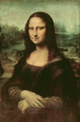
Pre-iconographic | Woman, landscape
Iconographic | Mona Lisa, Italy, three-quarter portrait
Iconological | Beauty, nature, contentment
(Figure 1)

“In the 1980s, information scientist Sara Shatford applied Panofsky’s model to indexing images. She relabeled Panofsky’s terms as generic (pre-iconographic), specific (iconographic) and abstract (iconological) and extended the model further by breaking each of these three levels into four facets: who, what, where and when. in figure 1, a generic who might be ‘woman’, while a specific who would be ‘Mona Lisa’. A specific where could be ‘Italy’, while an abstract where might be ‘nature’.
Another important aspect is why. The table provided below would be useful in gathering prospective details about an image, like the image above.

 | Generic (pre-iconographic), | Specific (iconographic) | Abstract (iconological)
Who | Woman | Mona Lisa | Beauty
What | Pose | Seated | Contentment
Where | Landscape | Italy | Nature
When | During Italian Renaissance | 16th Century (1503 – 1506)
Why |  |  | Beauty, Nature, Contentment

To adequately describe images we must have an understanding of an images visual content (percept vs. concept, semantics vs. syntax, and general vs. visual concept).

Percept vs. Concept
“Images are multi-dimensional representations of information, but at the most basic level they simply cause a response to light (tonal-light or absence of light) [21]. At the most complex level images represent abstract ideas that largely depend on individual knowledge, experience, and even particular mood. We can make distinctions between percept and concept. The percept refers to what our senses perceive, which in the visual system is light. These patterns of light produce the perception of different elements, such as a specific texture and a particular color. No interpretation process takes place when we refer to the percept: no knowledge is required. A concept, on the other hand, refers to a representation, an abstract or generic idea generalized from particular instances. As such, it implies the use of background knowledge and an inherent interpretation of what is perceived. Concepts, which can be described in different ways, can be very abstract and subjective in the sense that they depend on an individual’s knowledge and interpretation.”[20]

Syntax vs. Semantics
“While a percept refers to what we perceive through our senses (e.g., visual elements), syntax refers to the way in which those visual elements are arranged. When referring to syntax, no consideration is given to the meaning of the elements, or to the meaning of their arrangements. Semantics, on the other hand, deals with the meaning of those elements and of their arrangements.” [20] Syntax can refer to several perceptual levels; from simple global color and texture to local geometric forms, such as lines and circles. Semantics can also be treated at different levels.

General vs. Visual Concept
Jaimes, emphasized in his paper “Conceptual Structures and Computational Methods of Indexing and Organization of Visual Information”, that general concepts and visual concepts are different. “A visual concept includes only visual attributes, while a general concept can include any kind of attribute.” [20] He used a ball as an example. “One possible general concept can represent a ball as a round mass. Concepts for similar objects may vary between individuals. For example, a volleyball player’s concept of a ball may be different from a basketball player’s concept of a ball because, as described earlier, a concept implies background knowledge and interpretation. Note that, naturally, there is also a correlation between some general and visual attributes and visual attributes are a subset of general attributes. “[20].
Alejandro Jaimes and Chang went further and proposed a ten level pyramid structure for indexing visual information at multiple levels. The pyramid structure (Figure 2) is suitable for making syntactic and semantic as well as perceptual and conceptual distinctions. The multi-level pyramid allows classification of visual attributes and relationships at multiple levels. It allows for questions such as “What is the subject (person/object, etc.)? What is the subject doing? Where is the subject? When? How? Why?” to be answered.

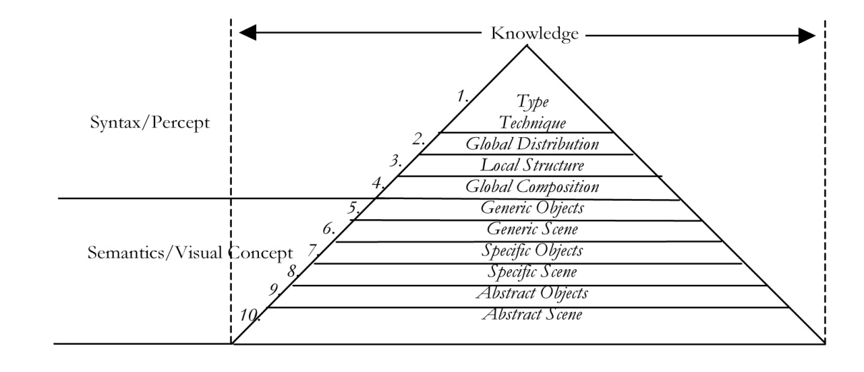
Figure 2: Ten level pyramid structure for indexing visual information at multiple levels

Semantics/Visual Concept Level | Description
Generic Objects | The level at which there are attributes common to all or most members of a category.
Generic Scene | What the image is of (set of all of the objects it contains). The guideline for this level is that only general knowledge is required. It is not necessary to know a specific street or building name in order to determine that it is a city scene, nor is it necessary to know the name of an individual to know that it is a portrait. When (general time: summer, winter), Where (general location: city, indoor, outdoor)
Specific Scene | This level is analogous to Generic Scene, but specific knowledge about the scene is used. Specific when, specific where, specific event. A picture that clearly shows the Eiffel Tower, for example, can be classified as a scene of Paris. When (specific time: 5th, March 1982), Where (place riel, louis pub).
Specific Object | Specific Objects can be identified and named. Specific knowledge of the objects in the image is required, and such knowledge is usually objective since it relies on known facts.
Abstract Scene | The Abstract Scene level refers to what the image as a whole represents (i.e., what the image is about). Atmosphere, Relationship, Symbolism, Emotions.
Abstract Objects | At this level, specialized or interpretative knowledge about what the objects represent is applied. Symbolism, Emotions, Mental states, Status, Relationship

Figure 3

“Generic Objects
Generic Objects Category (general category; what it is: tool, fruit), Generic Object Living (human, animal, plant, mythical being), Object Type (what it is - hammer, apple), Object Living Gender, Object Living Age.

Specific Objects
Specific Object Name (keyword/proper noun: ball peen hammer, Macintosh Apple,
President Bill Clinton)

Abstract Objects
Symbolism (Garden of Eden, Afterlife), Emotions/mental states (sadness, laughter), Relationships(brothers, romantic), Status (occupation, ethnicity, social status).

Generic Scene
When (general time: Middle Ages, summer), Where (general location: city, rural, seashore, indoor, office) Genre (landscape, portrait), Category (action and adventure, drama), General Event (type of event: parade, football game), Activity (writing, camping, gambling), Pose/Action (seated, standing, lying down, running, talking, throwing).

Specific Scene
Specific When (specific time: 1108, April 15.), Specific Where (New York City, Chrysler Building), Specific Event (Rose Bowl, Superbowl).

Abstract Scene
Subject (Subject/discipline: Geography, Engineering), Symbolism (Garden of Eden,, nature, urban life, power, freedom), Emotions/mental states (awe, fear), Relationships (friendship, competition, dominance), Atmosphere (overall feeling: gloomy, mysterious, carefree)”[40]

Combining the above table (Figure 3) with the why, when, where, what and who table we come up with the following model where for each significant objects within the picture we fill in potential information. The model shows that the when and where rows hold important information about the scene.
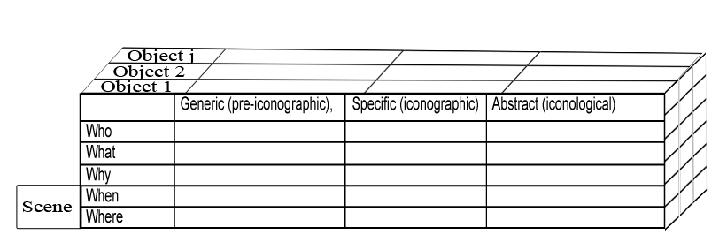
Figure 4

There are four main groups of images used on the web today. Decorative and branding, Formatting and text styling, Images as links and finally Informative images, with informative images being the most difficult to describe, this stems from the fact that informative images can be broken down into organizational charts, graphs, map and picture which in turn consist of different elements.

5. Method for creating ALT text:

(a) Identify what type of image the image to be described is:
- Decorative images: Images intended to usually stimulate interest or draw attention.
- Stylized text on images: An image that mostly contains stylized text.
- Images used as links: An image intended to serve as a link.
- Images within links: An image intended to be placed within a link.
- Form image buttons: An image intended to carry out a command when clicked.
- Icons and Logos: An image intended portray important visual indicator of association.
- Background images: An image intended to be used as a background.
- Informative images (Map): An image that serves as a map.
- Informative images (Pictures): A complex image intended to convey information.

(b) Based on the type of image follow the method below, guidelines 1 - 6 should also be put into consideration despite what type the image to be described falls under:
- Decorative images: Describe the feature or type of attention the image is intended to convey. [31]
e.g.
Graphic enabled browser.
 | In 2008 we joined forces with Student temps Ltd to provide quality student workers for Saskatoon’s booming economy.
Alt text: Picture conveying agreement. Picture shows two business people having a handshake.

- Stylized text on images: When an image contains stylized text, the text being displayed can usually be used as alternative text. [31]
e.g.
[31]
Alternative text = “The New York Times on the Web”

- Images used as links: The alternative text should indicate the target destination. [31]
e.g.
Alternative text = “Sign Up”
- Images within links: Whenever an image is within a link, the content and function of the image must be presented in alternative text within the alt attribute. [31]

- Form image buttons: Form image buttons should have an alt attribute that describes the function of the button. The alternative text should describe what the button will do when selected, such as "Search", "Submit", "Register", "Place your order", etc. [31]

- Icons and Logos: Icons and logos are important visual indicators of association. The alt field should be used to describe association; designers could potentially use a longdesc to describe the image. [31]

- Background images: If an image is used as a background for a page, it is not possible to include an “alt” attribute. As a result, we recommend that background images should not be used to convey content, where they are, the content must be repeated in text elsewhere on the page. [14]

- Informative images (Map): Write an alternative textual presentation of the information into a separate document, or into separate part of the document and link to it, this can be done using the longdesc tag or D-Link tag. You can then use the alt attribute to specify a condensed textual alternative, [32]
e.g.
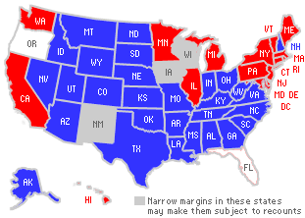
Alternative text = Map of united states showing which states electoral votes went to the republican candidate, the democratic candidate and are not known.
Longdesc can now hold information like which candidates won and by how many electoral votes.
- Informative images (Pictures).
    - Gather critical information: See guideline 7.
    - Identify the key objects within the focal point of the picture.
    - For each key objects identified above use information gathered from guideline 7 to fill fields in the figure 4.
    - After the information for the objects within the focal point of the picture have been collected within the table in the figure 4; try grouping the other objects within the image where applicable before inserting into the model, this will help trim down the model. See guideline 7.f and 7.g.
    - Trim down the model into a single who, what, why when and where table.
        - Information that is repeated in specific field across the various objects should be retained.
        - Specific who across key elements should be retained.
        - Specific what across key elements should be retained.

    - Present the picture and give a general view of it before going into details. [30]
        - Specific who and what should be included where the object in question is a key object and serves as an element within the focal point of the image.
        - Specific where should be included for objects that serve as focal point in the image.
        - Presentation must include at least a field from each of who, what, when, where and why.
        - Presentation should encompass all the key elements of the picture.
    - Locate each element of the picture before starting to describe the elements. (Guideline 8) [30] Where applicable.
    - Describe the picture in detail, once it has been presented and the different elements located. [30].
        - If picture is a painting or portrait, the Abstract (Iconological) field should be included in detail.
        - Information gotten from guidelines 9 is relevant to describing the picture in details.
    - If description is lengthy, end description with a short summary as it is a good way of returning to consider the picture as a whole. [33].

6. Guidelines
- Avoid being too brief that the context is confused. The simulation has shown that some people can only see the text in your alt tags, thereby if your alternative text is too brief, one might misunderstand the content. [23].
- Avoid using alternative text strictly for search engine optimization as this could backfire and result in your site being removed from search results.
- When creating alternative text use the clearest and simplest language appropriate for the sites content [2]
- “When an image contains only text, the text being displayed can usually be used as alternative text”. [16].
- Avoid using phrases such as “graphic of ….”, “image of….”, “link to….” Or “click this image”. As individuals already know it’s an alternative text for an image, a graphic or a link also JAWS (screen reader), for instance, will say aloud "link image” prior to reading the text alternative provided. Adding text such as "link to" means that those accessing the web with screen readers or speech synthesizers will be forced to listen to text that is, in fact, redundant. A further annoyance might result for skilled users of screen reading software. [14].
- Use everyday objects when describing pictures [9].

- Gather critical information
  - Figure out what information the picture is intended to convey.
e.g.
Motherly love | Betrayal | Jealousy
[24] | 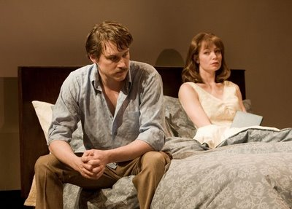[25] | 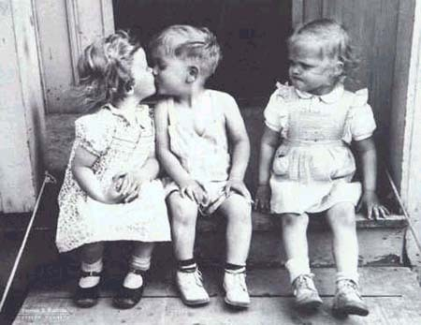[26]

  - State the purpose of the picture in your own words. [27]
e.g.
Advertised product, support context, beautify page, draw viewers’ emotions
  - Figure out the important elements within the picture. [27]
e.g.
A mother polar bear, 2 polar bear cubs, arctic region (icy region).
  - Figure out the relationships between the important elements
e.g.
Mother polar bear in the arctic, breast-feeding her two cubs
  - Figure out what emotion the picture evokes. [27]
  - Identify elements, such as colors and variations in shape and size of elements. [28]
  - Figure out patterns such as repeated things in the picture, people, shapes, and objects. [29]
  - Know the intended audience and what type of assistive technology would be used to view the web content. [27]
e.g.
Geographic, age, screen reader, sex.
- Locate each important element of the picture
  - Use accurate and specific language such as top/bottom, right/left, center.[9]
e.g.
The plate is on the right.
  - Relate the position of the elements to the most important element or a central element. [9]
e.g.
“The boy is to the right of his mother” given that the mothers location has already been specified.
  - Avoid using vague and less precise language to locate elements in the picture such as “over there”. [9]
  - The clock method could be used to help describe locations, as clock face directions are a simple and effective way to help the visually impaired put into perspective where an object is. [9]
e.g.
The car is at 12 o’clock
  - Difference in scale suggests that one element is further from us than the other.
  - Difference in texture (an element is more blurry) suggests that the element in question is further away than a less blurry element.

- People in pictures
  - Observe what the people or person in the picture is doing.
  - Figure out the expression of the persons, does the person express emotion or feeling? [36]
e.g.
Expressions:
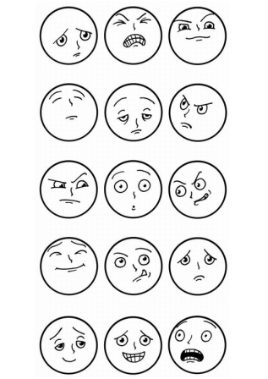[37]
  - Figure out the gesture of the persons’ body. What information does it express?
e.g.
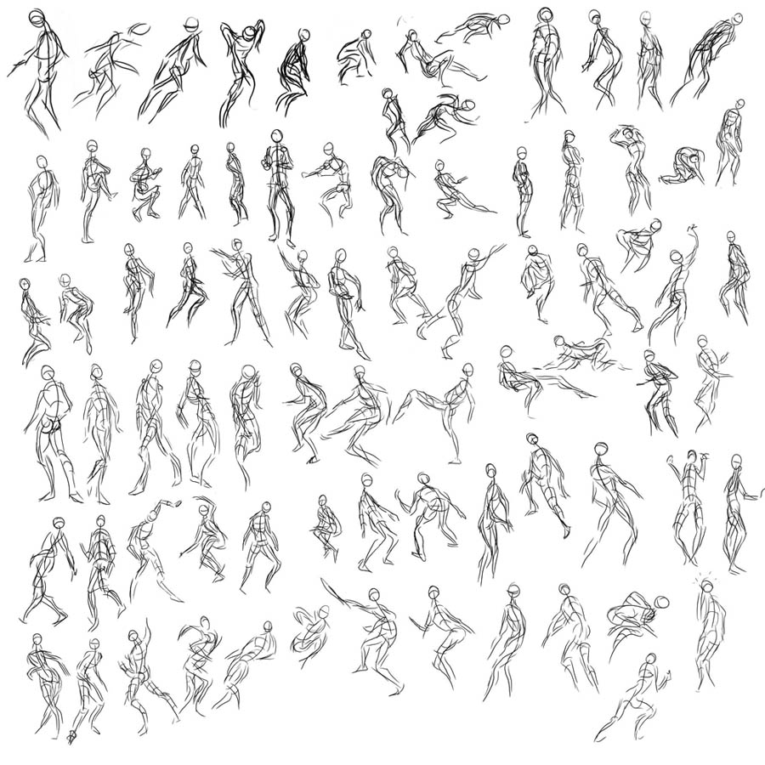[38]
Note: Describing and naming these gestures among others would be a good exercise in deducing information from ones gesture.
  - If relevant, other factors to consider include height, build, age, face shape (oval, square, heart-shaped, triangular, round), complexion (tanned, freckled, wrinkled, rosy, smooth), eyes (expression (piercing, sad, tear-filled, warm, sympathetic), shape and size (small, large, round)), hair (appearance/texture, length, color), clothes, and ethnicity (Asian, African, Caucasian, Latino).

7. Examples of applying these methods and guidelines
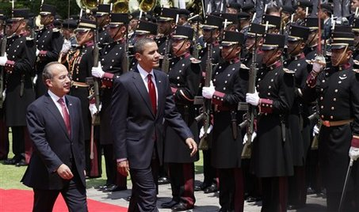[35]
a) Type of image to be described is:
Informative image (Picture).

b) Section 9 corresponds to the type of image to be described.
- Critical information:
Using guideline 7, I came up with the following important information: Diplomacy, international relation, international politics, visit, United States president Barrack Obama, Mexican president Felipe Calderon, Mexican honor guard, inspecting, walking, parade, partnership, red carpet, men, Mexico, government
- Key objects within the focal point of the picture:
President Barrack Obama, President Felipe Calderon, Mexican honor guard.
- Filling figure 4 for each key objects.
Object 1 | Generic (pre-iconographic), | Specific (iconographic) | Abstract (iconological)
Who | Men | American President Barrack Obama | International politics
What | Walking | Inspecting | International politics
Where | Outdoors | Mexico City | Government
When | Daytime | April 16, 2009 | Government
Why | Visit | Official Visit | Partnership
President Barrack Obama
Object 2 | Generic (pre-iconographic), | Specific (iconographic) | Abstract (iconological)
Who | Men | Mexican President Felipe Calderon | International politics
What | Walking | Inspecting | International politics
Where | Outdoors | Mexico City | Government
When | Daytime | April 16, 2009 | Government
Why | Visit | Official Visit | Partnership
President Felipe Calderon
Object 3 | Generic (pre-iconographic), | Specific (iconographic) | Abstract (iconological)
Who | Men | Honor guard | International politics
What | Standing | Parade | International politics
Where | Outdoors | Mexico City | Government
When | Daytime | April 16, 2009 | Government
Why | Visit | Official Visit | Partnership
Mexican Honor guard
- Grouping other objects within the image where applicable
A table has already been filled for honor guards which encompasses all the guard
- Trimming the model into a single who, what, why, when and where table:
Men, walking, outdoors, daytime, visit, Mexico city, April 16, 2009, official visit, partnership, government, international politics all have been repeated across the various object models.
Combined Objects | Generic (pre-iconographic), | Specific (iconographic) | Abstract (iconological)
Who | Men |  | International politics
What | Walking |  | International politics
Where | Outdoors | Mexico City | Government
When | Daytime | April 16, 2009 | Government
Why | Visit | Official Visit | Partnership
American President Barrack Obama, Mexican President Felipe Calderon, Honor guards are all key objects and thereby are retained.
Combined Objects | Generic (pre-iconographic), | Specific (iconographic) | Abstract (iconological)
Who | Men | American President Barrack Obama, Mexican President Felipe Calderon, Honor guard | International politics
What | Walking |  | International politics
Where | Outdoors | Mexico City | Government
When | Daytime | April 16, 2009 | Government
Why | Visit | Official Visit | Partnership
Parade and Inspecting are specific what (what the objects are doing) of the key elements
Combined Objects | Generic (pre-iconographic), | Specific (iconographic) | Abstract (iconological)
Who | Men | American President Barrack Obama, Mexican President Felipe Calderon, Honor guard | International politics
What | Walking | Parade, Inspecting | International politics
Where | Outdoors | Mexico City | Government
When | Daytime | April 16, 2009 | Government
Why | Visit | Official Visit | Partnership

- Presenting the picture and giving a general view of it:
The picture shows President Barrack Obama and Mexican President Filipe Calderon walking past and inspecting a parade held by the Mexican honor guard in Mexico City during an official visit on the sixteenth of April 2009.
Note: specific who of key objects (President Barrack Obama, Mexican President Filipe Calderon, Mexican honor guard), specific what of key objects (parade, inspecting) are all included in the presentation. Also note that the presentation contains at least one element from who, what, where, when and why field of the trimmed down table and the presentation encompasses all the key elements.

- Locating each elements of the picture:
Obama is in the center and to his right is Calderon, to their left is the honor guard.
Note: I related the location of the key elements to a specific key element (Obama).
- Describing the picture in detail
Both presidents seem content with the guards’ performance during the parade.
Putting Alt text together
Alt text:
The picture shows President Barrack Obama and Mexican President Filipe Calderon walking past and inspecting a parade held by the Mexican honor guard in Mexico City during an official visit on the sixteenth of April 2009. Obama is in the center and to his right is Calderon, to their left is the honor guard. Both presidents seem content with the guards’ performance during the parade.

 [41]

a) Type of image to be described is:
Icons and Logos.

b) Section 6 corresponds to the type of image to be described
According to section 6 of b in method for creating alt text, the alt field should be used to describe association.

Alt Text:
University of Saskatchewan.

8. Conclusion:
The examples have shown that the methods and guidelines are effective at adequately describing images for the web; this in turn makes the web images more accessible. It is worth noting that many of the design techniques that improve accessibility for disabled users also improve usability for other users. The method and guidelines in this methods can be used as – is for the type of images described in this paper. More research and development should be carried out in the future on omitted image types such as informative images (organizational chart).

References:
[1] WCAG 2.0: 2008, W3C Web Content Accessibility Guidelines - Guideline 1.1 Text Alternatives
[2] W3C (1999c): 1999, Techniques for Web Content Accessibility Guidelines 1.0
[3] W3C (1999a): 1999, Checklist of Checkpoints for Web Content Accessibility Guidelines 1.0
[4] W3C (2000a): 2000, Core Techniques for Web Content Accessibility Guidelines 1.0
[5] W3C (2002): 2002, Evaluating Web Sites for Accessibility
[6] Imagery and Verbal Processes: 1971 (Paivio, A.)
[7] Use of ALT texts in IMGS: 2003 (Flavell, A.)
[8] Concise, Scannable, and Objective: How to Write for the Web: 1997 (Morkes, J. & Nielsen, J.)
[9] CNIB: Canadian National Institute for the Blind, Saskatoon. (Information was gotten via tele-questionnaire with help desk, April, 2009)
[10] Guidelines on alt texts in img elements: 2002 (Korpela, J.)
[11] Renaissance and Renascences in Western Art: 1962 (Panofsky, E.)
[12] Analyzing the subject of a picture: A theoretical approach: 1986 (Shatford, S.)
[13] Journal of Visual impairments and blindness: 1993 (American Foundation for the Blind)
[14] How Accessible are Australian university websites: 2004 (Alexander, D)
[15] http://www.delorie.com/web/lynxview.html : Lynx text Browser:
[16] http://www.webaim.org/techniques/alttext : Appropriate use of alternative text
[17] http://iit.bloomu.edu/Spring2006_eBook_files/fire_vox/bad_alt/bad_alt.html : Simulation page:
[18] http://www.thefreelibrary.com/Intellectual+Access+to+Images-a059473802 : Intellectual access to images
[19] Query categories in a study of intellectual access to digitized art images: 1995(Hastings, S.K).
[20] Conceptual Structures and Computational methods for Indexing and Organization of Visual Information: 2003 (Jaimes, A)
[21] A primer of visual literacy: 1973 (Dondis, D.A.)

[22] http://www.w3.org/TR/UNDERSTANDING-WCAG20/text-equiv.html : Understanding Guideline 1.1 | Understanding WCAG 2.0

[23] http://webdesign.about.com/od/beginningtutorials/a/aa122004.htm : Alt Attributes: Describing Your Images for Better Web Accessibility.

[24] http://www.royalcopenhagen.com/%7E/media/Images/Figurines/Motherly%20Love/motherly-love-2-jpg.ashx?w=760&mh=400&bc=ffffff : Picture

[25] http://4.bp.blogspot.com/_Zaaa1HFB6uA/Sag9cV_ULPI/AAAAAAAAH1g/fBJdO0Sd63Y/s400/betrayal.JPG : Picture

[26] http://i144.photobucket.com/albums/r174/Cheebeez/kid-knows-jealousy.jpg : Picture

[27] http://education.eastmanhouse.org/discover/kits/files/11/analyze.php : Analize a Photo Document

[28] www.nipissingu.ca/education/jennifeb/educjb/ABQ_files/Ontario_Visual_Art _Expectations_2008.doc : Ontario Visual Arts Expectations

[29] www.mnstate.edu/sibley/EECE%20441%20Principles%20of%20Art.do : Principles of Art

[30] www.htctu.fhda.edu/trainings/manuals/alt/Tactile_Graphics.pdf : Creating Tactile Graphics

[31] http://cita.disability.uiuc.edu/courses/2003-02-REHAB711NC/lec05/index.html : Describing Images

[32] http://www.cs.tut.fi/~jkorpela/html/alt.html : Guidelines on Alt Text in IMG elements

[33] http://www.dinf.ne.jp/doc/english/Us_Eu/conf/z19/z19001/z1900116.html : How to make tactile pictures understandable to the blind reader

[34] http://htmlhelp.com/feature/art3.htm : Use of Alt texts in IMGs
[35] http://www.cnn.com: Picture
[36] Nyong, Ndon
[37] http://www.edupics.com: Picture
[38] http://sunshine-elaine.blogspot.com: Picture
[39] http://www.thefreedictionary.com: Definition.
[40] http://www.ee.columbia.edu/dvmm/publications/00/ASIS-SIGnov00_ana.pdf : Experiments in Indexing Multimedia Data at Multiple Levels
[41] http://beamteam.usask/images/usask_logo.jpg: University of Saskatchewan logo.

Simulation:
For most web designers, it is hard to visualize the experience of visually impaired users, users of text-only browsers, and graphical browsers with images turned off or experiences resulting from failure to download images because of network problems.
This simulation is designed to give designers an insight on the issues faced by these groups of users and put these issues into consideration during their design process. The web application that will be used will be a text-only browser called “Lynx Text Browsers”. Web designers can use this tool to evaluate their designs to ensure it effectively tackles the issues they encounter during this simulation. We will be looking at segments of the site http://iit.bloomu.edu/Spring2006_eBook_files/fire_vox/bad_alt/bad_alt.html using Lynx viewer application.
Choose your language:  -   -   -   -   -  | Choose your language:  * Country #001  * Country #002  * Country #003  * Country #004  * Country #005
(Figure 3.1: Display using graphical browser with images enabled) | (Figure 3.2: Display using lynx text browser)
Figure 3

Home  News  Downloads  Links  About  Contact Us | Blue star Home  Blue star News  Blue star Downloads  Blue star Links  Blue star About  Blue star Contact Us
(Figure 4.1: Display using graphical browser with images enabled) | (Figure4.2: Display using lynx text browser)
Figure 4

7. Simulation Questions:
Question 1)
What is the problem with this page while viewed using Lynx text browser (i.e. figure 3.2)?
Answer: The alternative text lacks meaning. It doesn’t specify the choices for the countries.

Question 2)
Does the alternative text in figure 3.2 successfully carry out its function?
Answer: It does not as Alt text exists to give users access to the information that would be conveyed by the image that they can't see either because of visual impairments or because of browser/device limitations. This doesn’t.

Question 3)
Consider using a screen reader, what do you think your experience going through figure 4 would be?
Answer: It would be really annoying, as one would have to listen to repetitive alt text that really does not make sense.

Question 4)
What do you think is wrong and how would you design this?
Answer: Decorative images such as spacers, bullets, etc. should have an alt that describes the type of attention or feature the image is suppose to represent.
It is important to involve users with disabilities in web accessibility evaluation as it has many benefits. One of the benefits of including people with disabilities is that web designers can learn how people with disabilities interact with the web and with assistive technologies.

