**“ I Match “**

**Hisham Mustafa**

Contents

Abstract 2

Background 3

Colorblindness 3

Blindness 5

Full Sighted individuals 6

Color and Style 8

Patterns 10

Methodology 12

Designing for the colorblind, full sighted individuals 12

Medium fidelity prototype 13

Components for development: 18

Identifying color from image: 19

Identifying colors that Match Well 20

Designing for the blind 22

Results and Evaluation 24

Evaluating prototype: 24

Redesign and advice: 25

Conclusion 26

References 27

APPENDIX 29

# Abstract

My project is going to provide a design for an I-phone application that would help the color-blind, blind and full sighted match colors when getting dressed.

The problem with matching clothes exists in all forms of colorblindness. The need for an application to aid the colorblind in matching clothes would greatly help individuals with this disability. The application can also be used by individuals who are full sighted, as a lot of people find it hard everyday, to wake up and pick out clothes that match.

The design of this application also includes blind users, who also struggle matching colors everyday. The tool can help blind individuals by aiding in the color matching process and easing up on the frustrations caused by not remembering what the color of each shirt is or incorrectly placing a blue shirt on a stack of red shirts.

Furthermore, this tool would be important to the field of accessibility computing because it will help make colors that the colorblind population cannot see accessible. By reducing the difficulties the colorblind face trying to match colors for an outfit to wear the disability itself tends to become transparent. The application will help diminish the frustrations caused by not being able to correctly identify colors. It will tremendously reduce difficulties in matching colors for the blind users and also for full sighted users that just happen to have a bad taste in color.

First, my project is going to give background knowledge about the three users identified by this project. Colorblind, blind, full sighted users with bad taste in color. Second, I will discuss color and style. Finally I will discuss a design for the application to accommodate the three users.

# Background

## Colorblindness

Colorblindness may be defined as the reduced or total lack of ability to differentiate between certain colors or wavelengths of light (Dalton, 1798). In fact the correct name for color blindness is color vision deficiency. Instances of red-green color deficiencies vary from one human population to another depending on racial origin. The highest rates are found in Europeans and the Brahmins of India (c. 8% of males) and Asians (c. 4%); the lowest in Africans (c. 2.5%) and the aborigines in Australia (c. 2%), Brazil, North America (c. 2.0%) and the South Pacific Islands, c. 1.0%, (Wyszecki, 2000).

Color blindness as a condition was first discovered back in 1798 by the English chemist John Dalton who was colorblind. He came to the realization that there were people who were totally unable to perceive colors, which some people readily identified, as red or green. He discovered that it was very rare to find the condition in women and that nearly 10% of all men in the United States suffered from one form of colorblindness or another. Color blindness is mostly hereditary. It is passed from generation to generation on the X chromosome and this explains why it is more prevalent in males (Jordan, 1993).

In as much as color blindness has on a lot of occasions been classified as a disability, studies by (HealthScout, 2001) have shown that colorblind people have the advantage of being able to penetrate certain camouflages as compared to people who can perfectly perceive color.

Some will say we all see art in our own unique way but that would only be true for the color blind. Visual impairment and deficiencies affect a significant amount of the population and is more common in areas with smaller gene pools. For those who see color, it is hard to imagine what a person with color blindness is seeing. Paintings in the museum and even the colored screens on our mobile phones are not the same to the whole population and funny enough there are those who can’t tell they have a color vision deficiency.

By understanding the science and logic behind the color theory we are able to help these individuals who have visual impairment and deficiencies. Before the overview of what this application can do for these people lets indulge in knowing a little about colorblindness, blindness and full sighted individuals.

There are many kinds of color blindness but they exist in two classes, those due to inherited color vision defects and those due to damage of the retina optic, nerve or higher brain areas.The different types of inherited color blindness result from complete or partial loss of function of one or more different cone systems. The most common here is the red-green heredity (genetic) photoreceptor disorders, which is also more common in males. Inherited blue yellow defects are however rare in both sexes (Goldman, 2004).

When a cone system is compromised dichromacy results. Dichromacy usually affects two in a hundred males; in these individuals there is no perceptible difference between red, yellow, green and orange. These individuals usually know they have a color vision problem. Dichromacy is further subdivided into three; protanopia, which is where shades of red are greatly reduced. Deuteranopia, this is where shades of green are greatly reduced. Tritanopia, this is where shades of blue are greatly reduced.The other form of color blindness also due to inherited color defects is Anomalous Trichromacy, which is further subdivided into three forms. One is protanomaly, where shades of red appear weaker in depth and brightness. It occurs in one out of a hundred males and is often referred to as red weakness, which is an apt description of this form of color blindness. Red, yellow, and orange to the protanomalous viewer appear shifted in hue towards green. It is so severe that the red a normal viewer sees in violet is weakened to this viewer to the point that violet becomes a different shade of blue.(Wyszecki, 2000).

The second is deuteranomaly, where the shades of green appear weaker. This person is considered green weak and it occurs in five males out of a hundred. This viewer makes errors in the naming of hues in the red, yellow, orange and green region because they appear shifted towards red (Subramanian, 2007). The main difference between the protanomalous viewer and the deuteranomalous viewer is that the latter doesn’t have a brightness problem. Some of these individuals may not even be aware of their deficiency because they go through life with minimal difficulty in tasks requiring normal color vision.

The third is tritanomaly, where shades of blue appear weaker; this is however according to (Subramanian, 2007) is very rare. These individuals usually have fewer problems in performing day-to-day tasks than those with protanomaly.

People with color blindness usually have problems starting from their childhood. Playing with crayons to a child with visual color deficiency is a hard task as they end up coloring in a manner not expected for instance a child may color the ocean green. This causes the child to fail or not pass as his potential allows them to. Other areas which require color to be identified like, traffic lights, cooking, watching the television and even alerts that beep different colors for different situations usually create inconveniences to people who are unable to interpret them correctly (Spring & Matthew, 2006).

It’s important to stand out of the crowd but not for the wrong reasons and that is what most individuals with color blindness understand clearly. It is usually hard for color blind people to match their cloths both for wearing and while shopping .It is not only important that when you go out shopping to have personally empowering information but also good color vision.

Most of these individuals have a huge dependency on the people close to them to ensure that they dress presentable, and shop for matching outfits. Those who are married depend on their spouses; while it is mostly those who want to have an impression on other people they don’t know who find it hard. They usually choose a sister, a friend sometimes their moms and this most often if not all the time leads to shopping disasters. Even after buying it is still challenging to match cloths and some even go as far as numbering their shirts pants and socks so that they know which cloths go together. Even with the numbering some confusion will sometimes occur according to their kind of color blindness that is one may confuse a green shirt for a blue shirt.

These errors can be reduced by the invention of the automated cloth matcher. This is needed because a helping hand may not be available at times where a colorblind individual is alone. In this generation where color recognition technology is possible it would be a major boost and will help people with color deficiency.

## Blindness

Every year thousands of people go blind mostly as a result of advancing age with as many as half of the blind people considered to be above sixty-five (Kokotailo, 2006). However a significant number of the blind are children and young adults. There are many causes of blindness but the major causes are; cataracts, which are opacities and cloudiness of the eyes, lens this blocks passage of light through the eye some people are born with cataracts but they increase with age. Other causes are diabetic retinopathy, glaucoma, macular degeneration and retinitis pigmentosa.

The blind on the other hand have a bigger problem when it comes to dressing and shopping. It’s important to match any clothes you buy with what you already have at home in your closet. This helps match your existing outfit and avoids clothes that will look odd both of which save money. To the blind insufficient development of other senses of perception increases their desire to see and better comprehend what the power of sight actually is. This will cause them to want to dress respectfully and above all look good to the rest of the world thus clothing to the visually impaired mean a lot to them. They know that the power of sight is an ability possessed by others that enables them to see things, which they cannot.

For the blind it is a different case, it’s interesting to talk of color and blindness. It’s actually fascinating to find out that color does have a meaning to a blind person, therefore their dressing and shopping does matter. This in consideration, most of the people who are blind have lived with sight for some time and therefore appreciate color. Coordination of a blind person’s closet can be accomplished with help from close family members and friends and also various techniques of clothing care and also various sewing techniques.

These techniques include, use of safety pins that are used to identify colors in clothing. The individual usually makes up their own system for colors and their positions. It simply involves the placing of a pin in a specific hidden position for each color on each cloth. Also the use of French notes and yearn notes can be used in a similar way as the pins, marking differently for different colors (Yanoff, 2004). It is however more convenient for a blind person to have more clothes of one color than another so that they are preferably not identified with any pins and markings. This technique is however only for those who have had their visual impairment from infancy, as it needs vigorous training.

Fears of the blind are almost identical to those of little children although the great emphasis on the blind side is the fear of being alone or having to do something they cannot do due to their blindness. This is because of the constant dependence on other people. Also the education of the blind appears not to be sufficient to enable them adapt to their special needs, therefore it is applications like this that are set to pave the way for the complete adaptation to their needs .To the blind therefore the effects are the same as they will have a companion that can respond to the little questions they have in their heads but can’t ask people around them all the time. This will in way help reduce their fears, as it’s a task of the burden of other people creating a sense of independence.

Recently shopping for clothes for the blind has been made possible by inventions such as the Bright-F cloth scanner, which allows the person to know the color of the fabric by simply speaking the color after scanning (Hilbert, 1997). This therefore helps a blind person identify colors of clothes but does not help them match 2 items, which ‘ I-Match’ can do.

## Full Sighted individuals

Full sighted populations are believed to make a subconscious judgment about a person or environment within some seconds of viewing, and a high percent of that judgment is based on color (Yanoff, 2004). Therefore for full sighted individuals, color is powerful and matching it is essential. Full sighted people match colors in different ways and for different reasons, for example color matching of printing colors, of frames of glasses and many more each having a different variable. The viewer can reject a color that they found forthcoming the previous day just because they didn’t sleep well. This is to show that there are many variables affecting the way color is perceived and if any of then changes so does the appearance of the color to the viewer.

Full sighted individuals can choose to color match with a color measurement device, which is a science, or without one, which is seen as an art. With both situations three things must be present in order for color to exist; the first is an object, second is light to illuminate the object and an observer or a color matching or measuring device (Yanoff, 2004). These are the three components that contain all variables that affect color-matching capabilities. These variables all depend on the object being viewed the shape, texture and surroundings.

Matching of colors in full sighted people also depends on what it’s perceived the color stands for (Smal & Hilbert, 1997). Red for example prompts people to buy which is the main reason there are many red cars at the dealership, while blue is considered a calming color. This means they match color to determine the perception people will have about them. People may also match their clothes depending on occasions like black for funerals and other bright colors for the good times.

People considered to have bad taste on the other hand are in a class of their own. They are people with full sight but their color matching tends not to impress the subjective eye of the viewer. This is to say that a person’s style quotient is reflected by their taste in their clothing and accessories. People with bad taste although with the same sensitivity to variables that change appearance of color, usually have one or two accessories that eclipse their sense of style. It’s also possible that people with bad taste go for clothes and accessories because of its color without considering the texture and the surroundings they are in. This is because the surface characteristics play an important role in perception of an object to a person (Shevell, 2003).

Most consumers throughout the world have impaired vision or limited color vision as part of congenital illnesses and, yet most organizations and companies don’t specifically consider their needs and capabilities. The application that is being proposed for an I-phone that helps colorblind, blind and full sighted will tremendously uplift this peoples lives. This will act to improve the self-confidence of these people for the simple reason that they will be able to choose things for themselves and not have doubt for once that they might have made the wrong choice. It also provides them with a further sense of independence as they stop their dependence on those around them.

Test strips of pH, hard water and swimming pools, which a colorblind person is unable to interpret, are made a reality to these individuals. Usually the red traffic lights contain some orange in its hue and the green light contains some blue. In other words they will be able to fit into the normal routines they couldn’t perform before those, which made them, feel impaired.

For those with a bad taste this will help them stand out for the right reasons. It makes shopping easier since those decisions that seemed hard or were argued about will be easily settled by the pressing of a button.

This application is further seeking input from the blind consumer, the colorblind consumer and even the ordinary Joe that just seems to have a bad taste when it comes to matching colors. This can be supported by the fact that studies of consumer reaction to advertising packaging and other informational cues traditionally assume that the visual capabilities of the consumers are within a relatively standard range of color capabilities.

For the most part this is not a demand for equal visual rights but an effort to ensure we make lesser color bladders by using this application. This is because there is a very good chance that probably you are working near or know somebody with a color deficiency, so having them see things the way you intended them is a great way to make sure your message is correctly passed over.

It is then clear that this application is a step towards helping the blind and visually impaired move a step closer towards truly learning to live independently in the community. They will be able to appreciate and adapt to the new technologies, as they will be able to access new areas they couldn’t as a result of their impairment. An example of how this tool can be used in the future is in laboratories where it is impossible for a colorblind person to tell the colors of the chemicals and might put themselves in danger.

With their impairments these people especially the blind, need technology in their daily lives to communicate, access information, communicate to complete their education and most importantly to gain information about jobs and life in general. These people try out various hardware, and software to find the one that suits them the best and ‘I-Match’ application for the I-phone will provide that edge for them.

In those who already depend on technology for daily routines such as organizing schedules and appointment information, pay bills, e-mail information, and research on the Internet this application in the future can help make colors accessible and provide aid to different technologies used everyday by people.

This application will also help the biasness towards the visually impaired die down as it has grown to a point almost to be referred to as a form of racism. This application in the future therefore will help especially the colorblind designers, advertisers and many others who are the minority justify that they are capable of doing what fully sighted people can do. This will help those in industries that deal mainly with color to put colorblind racism in the past, since everybody will be able to see things the same way and interpret them in there own unique way.

## Color and Style

Andy Gilchrist is the designer of [www.askandyaboutclothes.com](http://www.askandyaboutclothes.com), he has degrees in sociology and journalism (Gilchrist, 2009). Working at a Ralph Lauren store he developed a strong sense of how fashion plays an important role in influencing people. He was constantly the number on salesman He developed the site to help people who have a hard time in picking colors when dressing up. The website started of with a very small number of hits per day and eventually by June 2007 it was averaging 600,000 hits per day. His work was noticed and he wrote articles for some big names such as Men’s Health, Forbes, and GQ magazines, Classic style magazine. He also developed ‘The Encyclopedia of Men’s Clothes’ and produced a CD version. Gilchrist’s website as a result has attracted the attention of the New York Times and Playboy Magazine which helped in increasing the number of hits on the site (Gilchrist, 2009).

The main point behind this project is to aid the user into dressing up with in the right colors. Understanding color is an essential step into understanding how to match. Unfortunately we live in a society where when people meet they tend to remember only the bad things about each other (Gilchrist, 2009).

First lets describe color and its different components. Analyzing a color can be done based on 3 properties, which are hue, value, and intensity. Hue is the actual name of the color; Value is how much lightness or darkness a color holds, this can be described by shades, tints, and tones; Intensity refers to the saturation of the color (Gilchrist, 2009).

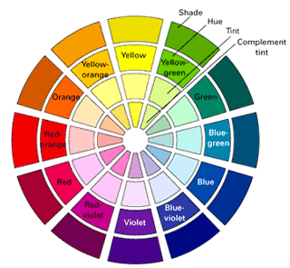

Fig 1.0 (Gilchrist, 2009).

The above diagram is the color wheel, which shows tint, hue, and shade and compliment tint. Tone refers to the hue and a small amount of gray or opposite color, the result is either a toned down color or a mute color. Tint refers to the hue plus a white added to it to lighten a color. Shade refers the color plus a black added to it to darken the color (Gilchrist, 2009).

Core Color refers to the most dominant color in a color scheme (Gilchrist, 2009). Accent of a color refers to the second or third color used in the scheme. The primary colors in a color wheel are Red, Blue, and Yellow. Mixing these colors together will result into the rest of the colors. Secondary colors in the color wheel are a result of mixing the primary colors. Complimentary colors are colors that are placed as opposites on the color spectrum. This an explanation why hunter green pants goes well with a burgundy sweater or shirt (Gilchrist, 2009).

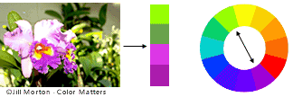

Fig 1.1 Complimentary colors (Gilchrist, 2009)

Analogous colors are colors placed adjacent to each other on the color wheel. For example blue pants, blue-green shirt and a green jacket are classified as an analogous match and they look good together (Gilchrist, 2009). Figure 1.2 shows analogous colors.

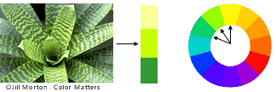

Fig 1.2 Analogous color (Gilchrist, 2009)

Colors are also classified as warm and cool. Warm is associated with Red, Green and Orange. Cool Colors on the other hand are Green, Blue, Violet. Designers usually build schemes by mixing warm and cold colors. Selecting two cold colors and one warm or vice versa will create a harmonious match. For example A navy blue suit (warm), light blue shirt (cold) and a red tie (dark) go well together (Gilchrist, 2009). Figure 1.3 below shows warm and cool.

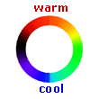

Fig 1.3 Analogous color (Gilchrist, 2009)

Neutral colors usually refer to White, Black, Grey or beige. All the different shades of each of these colors are considered part of the neutral colors. For example a white T-shirt black pants are considered neutral colors. What you wear may also be inappropriate depending on the time of year. Pastel colors and bright colors are considering spring and summer colors while brown green and burgundy are associated with autumn. Also when dressing up thinking in terms of contrast is important. Choosing one dark element and complimenting it with two light ones is an example of contrasting (Gilchrist, 2009).

## Patterns

Pattern of a piece of clothing can play an important role when matching clothes. So far we have discussed color and how to match by just looking at color. Unfortunately, Color is not the only thing that people look at when matching clothes. Other elements also play a role in determining the perfect match.

According to (Gilchrist, 2009), These are 4 elements one should look at when matching clothes are the following:

* Color
* Patterns
* Fabric weight
* Fabric Texture

We have discussed color and its properties. This project will deal with color and color of patterns. Weight, Fabric texture are both outside the scope of the project. I will provide a brief explanation of the last 2 elements.

Pattern matching can be difficult if not understood properly. People tend to remember solid colors the most, solid colors make you look more elegant (Gilchrist, 2009). The principles of mixing patterns is analyzing each pattern for the following:

* Size of pattern
* Type of pattern
* Color
* Intensity

Mixing 2 or more patterns can be done but there are certain things to watch for. The color each of each pattern should match; also the type and size of the patterns should not be the same in the two chosen items (Gilchrist, 2009). For example a check shirt a tie with small patterns would go very well. The application does not deal with pattern types or sizes and would not be able to recognize shapes and size. The application is mainly concentrated on dealing with color and since patterns involve color, the colors of the pattern are matched to the second item. For example the patterned shirt below contains dark blue stripes going horizontally and vertically. To match this shirt to some pants we look at both colors on the shirt to see if they match with the trousers. White is considered a neutral color like stated above so we match the blue to the pants. If they match correctly then it’s a good match. More information on matching will be provided in later sections.

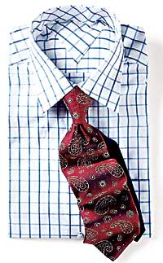

Patterned shirt (Gilchrist, 2009).

Fabric weight is used to describe how heavy you look in a piece of clothing. Wool, corduroy, suede and leather can be described as heavier fabrics than seersucker and linen (Gilchrist, 2009). Heavier fabrics give the impression of a heavier a person and lighter fabrics give the impression of a thinner person. Fabric texture usually describes the roughness or smoothness of the piece of clothing. (Gilchrist, 2009)

# Methodology

## Designing for the colorblind, full sighted individuals

I will now explain the design for the 2 users and I will follow it by snippets of medium fidelity prototype created to give a view of how the interface looks like. In this project, I aim at designing a tool that can aid people who are not capable of matching colors. This population of people ranges from colorblind and blind to fully sighted individuals who can’t get there colors right. This will provide a solution that can help them go around the problems they face when they come face to face with colors. ‘I-Match’ will allow individuals with colorblindness; blindness or the full sighted match colors when dressing up in the morning or even when at a store buying new clothes.

*When the application starts the following menu is presented to the user:*

* ***Take a picture***

Note: Allows user to take a picture and deduce a color, save

* ***Match Items***

*Note: It activates the ‘Match items’ menu, which contains more options*

* ***Exit***

The colorblind, fully sighted users will click on ‘Take a picture’ and this will allow the user to take a picture of a blue shirt for example. The user can choose to place a white background behind the blue shirt to cancel out any interference from background colors. The placing of a white background can also help in making sure brightness does not play a factor in the color matching process. If the user does not have a white background in hand, the user can take a picture and simply point down on an area of interest on the piece of clothing on the screen. After the picture is taken the application analyzes the colors and provides the user with the main color of the shirt, and displays the name on the screen. The user will then proceed to save the picture if he or she chooses to. The pictures are saved to the pictures folder. Once the picture is saved the user can then use the saved picture (blue shirt) to match some pants in a store. At anytime the user can return to the previous menu by clicking back.

If the user chooses to match a saved item to a piece of clothing in a store .The user will simply select the ‘Match Items’ feature provided by the program which will display a new menu for the match Items. The menu is provided below in bold font. The user will proceed by clicking ‘Match New Items’. The user will choose a picture from the gallery, for example selected blue shirt and then point the device onto any item in a store to match. The application will analyze the colors and provide a confirmation to the user if it matches based on its set of predefined colors. In the processing of the image and color stage, the application contains a list of predefined colors that the matching is based on.

The menu for the match items option will include the following:

* **Match saved items**

Note: Match saved items will allow the user to match 2 items in gallery

* **Match New Item**

Note: Allows user to match a saved item to an item fed from the camera

* **Gallery**

Note: Access to saved items

* **Back**

The application can also match 2 saved pictures. The user will then select two images saved in the gallery. When the two pictures are displayed on the screen the user can point at the areas of interest in each picture. The program can be modified so if the saved items contain a white background there will be no need to click on an area of interest. The matching will automatically be done when the 2 pictures are selected. For now we will assume the user selects and area of interest on each item. The program will then proceed to analyze colors and match the 2 areas of interest. If a match is good the program will confirm a positive match up. The feature allowing the matching of 2 saved pictures is good if a user is in a hurry and just wants to take a quick picture of a piece of clothing and match it later. Color processing is also done based on a predefined set of colors within the application.

## Medium fidelity prototype

The following prototype demo was created using Omnigraffle to create a fully functional look of the application. I used the I-phone stencil downloaded from Omnigraffle website. The stencil looks like the I-phone and provides the capability of adding buttons and other parts of the interface to build a look of the desired application. Since the prototype can only be run by a Mac I have provided snippets of how the application functions. I will also be providing the prototype copy. Please note the menu options are selected in sequential order to show the functionality of each item on the menu. Next page provides snippets and descriptions.

***1****)*

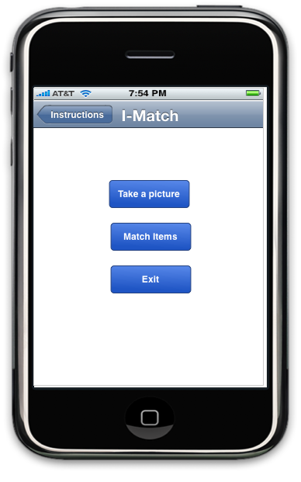

**Description (1):**

This is the menu the user is presented with when the application is turned on. The

User selects ‘Take a picture’ and is presented with the screen shown in (2).

***2****)* ***3****)*

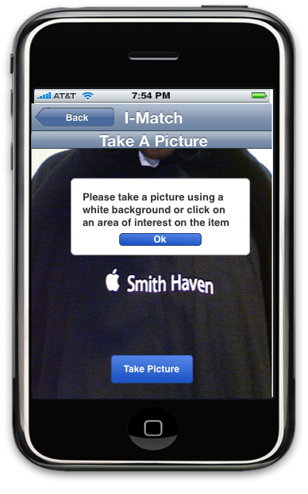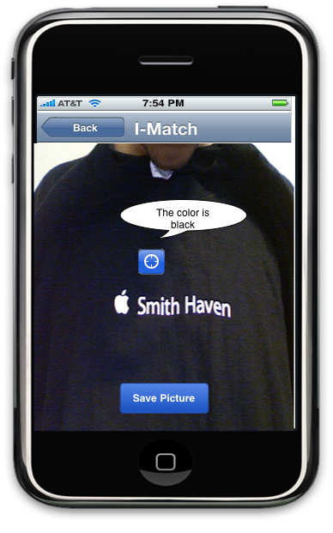

4)

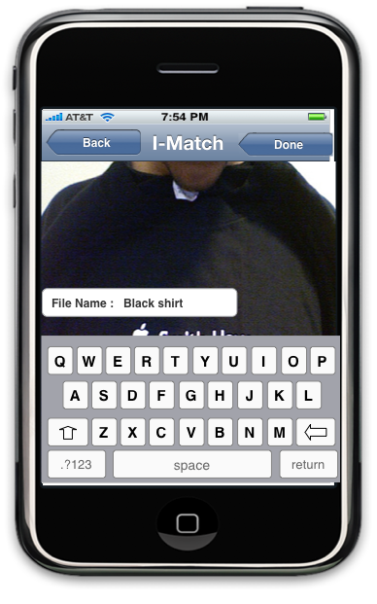

**Description( 2,3,4):**

Here the user is pointing at a black T shirt. The progrma asks him to select an area of interest or if the user is using a white background then the use can just click on “Take picture”. The program will analayze the color and return a color name to the user. The user can save the picture according to the color name given as feedback from the program as seen in 3.

**5**) **6**)

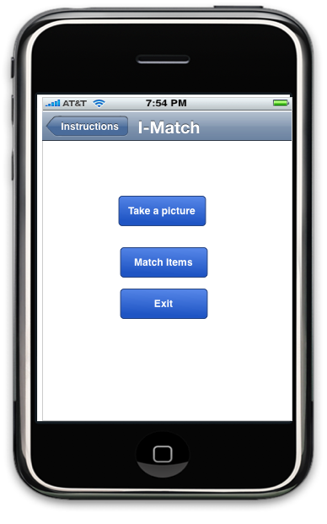 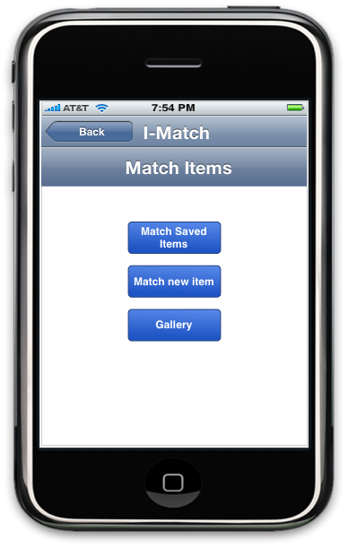

**7**) **8**)

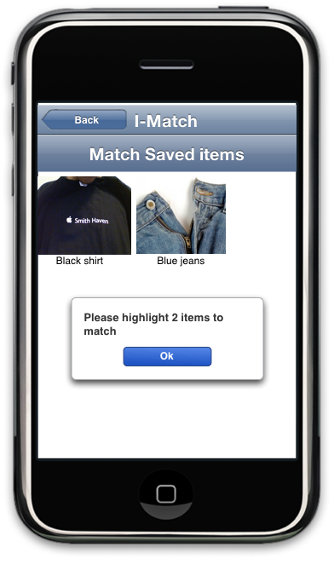 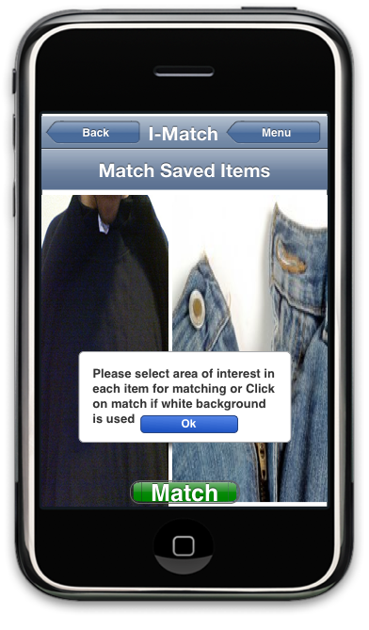

**9)**

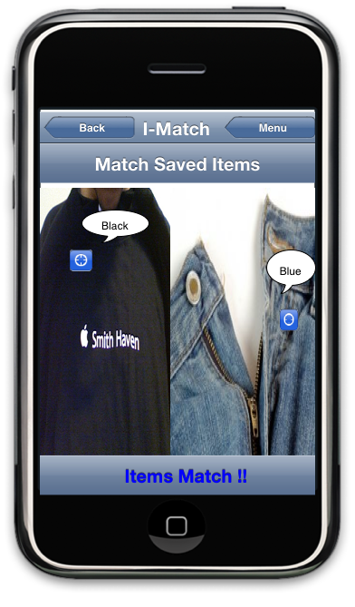

**Description( 5,6,7,8,9):**

Here the user is Back to the main menu in (5). He then proceeds to selects ‘Match items’ located as the 2nd menu item. The user chooses ‘Match saved items’ in the Match Items interface. The user is asked to select 2 pictures from gallery in order to perform a match as seen in (7).In (8) the user is asked to select 2 areas of interest from both pictures and interface window (9) tells the user if the 2 pieces of clothes match which in this case they do.If the user has a white as background in each clothes item then he can choose to not select and area of interest but to just click on match and the output will be the same as in (9).

**10) 11)**

 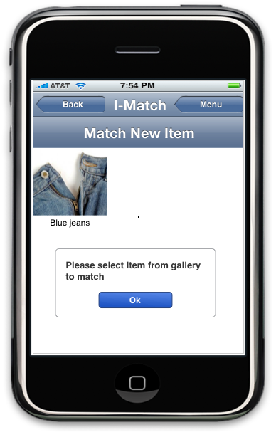

**12) 13)**

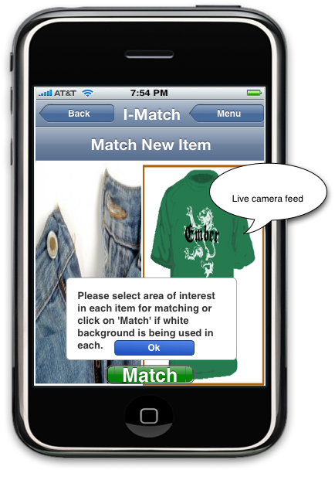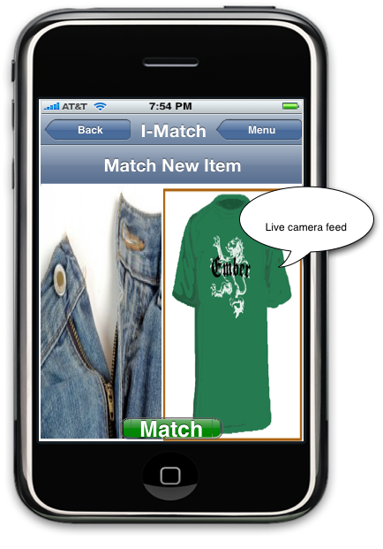

**14)**

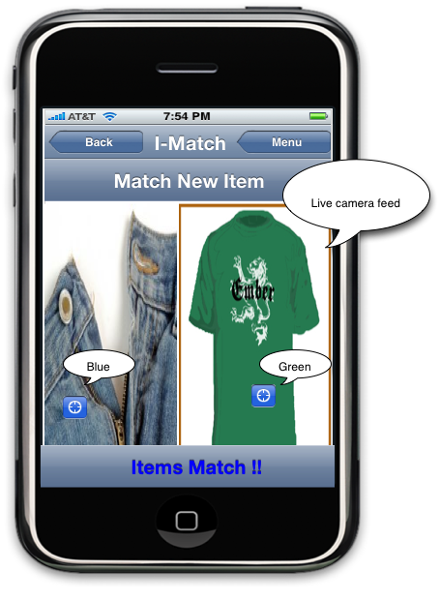

**Description(10,11,12,13,14)**

Here the user chooses Match new items as he wants to match an existing item to a live camera feed from the camera.In (11) the user is asked to select an item from the gallery of saved items. In (12) the item is maximized and the screen is split into a camera feed and the item chosen from gallery.The user is then asked to selet and area of interest on each item or simply click match if each item contains a white background. This includes a white background in the live camera feed half of the screen.In (14) the user receves a feedback if a match is succesful.

For the full sighted individuals with a bad taste in color, the prototype can be used to evaluate the application. In terms of their disability to match colors, the program will treat these users as it does with the colorblind. The interface is the same for fully sighted individuals.

For the blind it was impossible to create a medium prototype of the interface they are presented with since the interface is kept very minimal in terms of visual elements. They’re menu as I have stated is in auditory form and they control menu items through voice recognition. This is why it was hard to find the appropriate prototype that would stimulate what the blind go through using the application. The application has to be implemented and then evaluated using 5 to 10 blind users to get a feedback about their experience and to see what they would like added to the application.

## Components for development:

As I-phone development can only be done using a Mac computer, the requirements for development are limited to Macs only (Mac Os). The language used for development is the object C, which is a superset of the C language. According to (Apple, 2008) for implementation, Xcode IDE can be used as it provides an easy way to develop GUI based applications. X-code provides useful tools to help easy development these tools consist of the following:

* **Interface Builder**

It provides the user the ability to create GUI designs graphically and save them for later user for resources.

* **I-phone simulator**

This mimics the I-phone API, providing the user the ability to run the application without needing a device.

* **Instruments**

Instruments provides the user with the ability to see what the code is doing while it is running. You can view and analyze data as you go.

* **Shark**

This is a very useful tool; it can be used to figure out where time is being spent in the application to improve performance (Apple, 2008).

The bundles of the application are usually folders that named with an application extension. The programs and contents are kept in the folder which supports media inform of images and audio. The key image files are normally two: icon png and default png, icon png represent the application on the home screen while the default provides splash screen, which displayed during the launch of the application.

Audio recording and audio playback are also part of the design since the blind need auditory format in order to navigate. The I-phone supports different audio formats, which include MP3, AAC, ALAC, IMA4, and Linear PCM. Now since the audio is created for the blind, precise control is needed to synchronize the audio with the navigation. Apple provides an Audio Queue Service. This provides a simple way to record and play audio, it also gives the ability for very accurate timing control to support scheduled playback and synchronization (Apple, 2009). This is helpful in synchronizing audio playback with navigation for the blind.

## Identifying color from image:

The application uses pixels from the image taken or the image saved to analyze the color. A pixel is a RGB value (Red,Green,Blue). Each component represents a number ranging from 0 to 255. For example the color orange is represented by (250,165,0). Each component value represents the amount of shade, so the red component can have a shade ranging from 0 to 255. Mixing shades of other colors produces new colors. Black is represented by RGB (0,0,0) and white is represented by RGB (255,255,255)(Fulton, 2008). The I-Phone can display at 480 by 320 pixel resolution (Apple, 2009). The number 480 represents width and 320 represent the height.

The picture below is a picture of a hot air balloon blown up to 10,000 the size of the original photo located on the left. The purpose of this is to show how every image really consists of millions of pixels that create a smooth look.

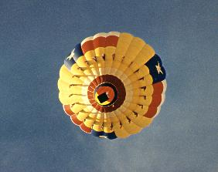 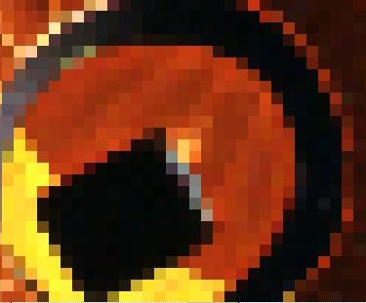

Hot air Balloon (Fulton, 2008). After 10 times zoom (Fulton, 2008).

For the purpose of identifying a color from an image, pixel manipulation is done on each pixel in the photo to deduce the color. The first item in the menu in the ‘I match’ application is ‘Take a picture’ which as stated above allows the user to take a picture and deduce the color of the piece of clothing. The idea of deducing the color is to retrieve RGB values from each pixel in the image. Defining a pixel struct to hold data about the pixels can help do this. The values can consist of R, G, B, and A. The last component ‘A’ the alpha component deals with transparency, which is outside the scope of the project.

Apple has allowed access of pixel data through the use of the CGDataProviderCopyData call (Apple, 2008). This call using the image as a parameter returns a CFData object that contains the pixel data about the image. When the pixel information is obtained the method CFDataGetBytePtr can be used to point towards the pixel data or CFDataGetBytes to get a range of pixel data desired. Prior to the development of the Mac OS X 10.5 obtaining pixel data was more complicated but now Apple has allowed this to be easier with CGDataProviderCopyData (Apple, 2008). Now we have the ability to retrieve R G B values in each pixel in the image. When the user places a white background the values of the R G B is 255,255,255 respectively. When analyzing an image for a shirt or a pair of pants we can choose to ignore R G B values of 255,255,255, which represent white. Ignoring all pixels composed of white will result in only pixels that contain the color of the actual piece of clothing. For example a photo that contains a yellow t-shirt will result in let’s say 100 pixels and each pixel consisting of values R (255) G (255) B (0). These values represent the color yellow. Since the application can only identify colors of pixels in

terms of R G B values the application will contain a list of predefined colors. The colors each have different R G B values and are placed in a Color table located at the end of document. When a picture is taken the values for the pixels chosen are compared to the Color table and if the values match some RGB value in the table, the color name is extracted and shown to user. The color table of course can be easily copied to form an Array to easily accommodate matching.

This would work for pieces of clothing that are one solid color. For pieces of clothes that consist of colored patterns the method still ignores the white pixels but now the problem faced with is the rest of the pixels may contain 2 or more different colors. For example let’s go back to the patterned shirt we saw earlier. As you see below the shirt (Ignore the red tie) contains the colors blue and white. We find out the color values of each pixel and group same values below the same color name. Obtaining pixel data tells us that N pixels (N is number of pixels) have the RGB value of (0,0,205) which represents the color ‘Medium Blue’ available in the color table. Also X pixels (X is number of pixels) have the value (255,255,255) which represent white in the color table. Now we have identified 2 colors and according. If X> N we can say that X pixels represent the dominant color and N pixels represent the accent color.



Patterned shirt (Gilchrist, 2009)

## Identifying colors that Match Well

We now need to identify a way for identifying a good match. For example we know that a white T-shirt matches well with blue jeans. According to Gilchrist the neutral colors are shades of white, gray, black or tan. This is why a white T-Shirt would match well with any color of jeans, even pink. Now the first rule for matching would be the simplest and deals with neutral colors.Shades of white, gray, black and tan match well with any color, the user is provided with a positive match if these colors are involved. If we look at the color table provided in the appendix we see that Id 1 to 124 contains shades of Black and Gray and Id 71 to 609 contain shades of White. Any color with the RGB values ranging from Id 1 to 124 and 71 to 609 are considered neutral colors. This covers the neutral colors and their different shades supported by the application. Of course some clothing items may contain more that one color so based on this rule the neutral colors will be ignored and the matching will be done on other non-neutral colors available.

Now that neutrals color are out of the way, we move on to matching other colors. We know that warm colors are red, orange, and yellow. Cold colors are green, blue and violet. For the warm colors red, orange and yellow the different shades of each color is as follows according to the color table:

* Id 426 to 498 represents different shades of red.
* Id 374 to 424 represents different shades of orange.
* Id 611 to 658 contain different shades of yellow,

The cold colors green, blue and violet and their different shades is represent as follows in the color table:

* Id1 26 to 256 contain shades of Blue.
* Id 300 to 372 contains shades of Green.
* Id 500 to 569 contains shades of Violet.

According to Gilchrist selecting 2 warm colors with 1 cold or vice versa creates dynamic harmony. So blue jeans, which are considered to be cold in color, would go well with a shirt that is striped with 2 warm colors (red, orange and yellow). Again Neutral colors don’t exist when dealing with other colors as they match with any color. We also now know that complimentary colors are colors that are placed opposite to each other on the color wheel. So shades of red go well with shades of green, also shades of blue match well with shades of orange etc. Using complimentary colors and analogous colors we can identify a way to produce positive matches. When the user wants to match blue jeans to a light blue shirt the application uses pixel data obtained from pictures to match color names in its predefined data. Once this is accomplished the program will then use complimentary colors and analogous colors as a way to determine if both items produce a harmonious match. If a piece of item contains more than one color as stated in earlier section we gather pixel data and deduce the number of colors. These colors are then matched to the most dominant color. The most dominant color represents the color that represents the highest amount of pixels.

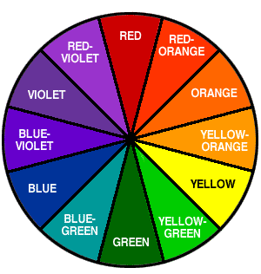

Color wheel (Gilchrist, 2009)

## Designing for the blind

For the blind users, the requirements are different. Blind people are not able to see the screen unlike the other users Colorblind, non colorblind. This provides a problem of making the application accessible. Since the I-phone does a poor job of accommodating the blind it makes it impossible to be able to navigate to the application location. For this reason the application can be accessed while the I-phone is switched on, by moving the I-phone in a circular motion. The circular motion can be counter clockwise or clockwise to avoid any confusion. Once the user has completed the circular motion, the program will automatically lunch. The user is notified through auditory form, the phone will for example say, “ I match running”. When the loading is complete within a few seconds a menu is listed to the user in auditory form. The menu can be interrupted at any time by the command “repeat”. This will be called by the voice of the user. The repeat command will repeat the items on the menu.

The options in auditory for are the following:

**1) Voice settings**

1. **Take picture**
2. **Match Items**
3. **Exit**

Note: Exit will save any settings changed by the user in terms of customization

The first setting “ Voice settings” is to allow individualization, because the power of individualization is important in the design. Users have different capabilities and the need for individualization is to accommodate different users since there is a variation in user characteristics (ISO 9241-129). Also there is different goals and needs for different users. This is following the ISO 9241-129 Guidance on individualization. The capability of changing voice settings allows the user to have a predefined user profile. The settings for voice are saved and the next time the user loads the program they don’t have to worry about changing the settings again. The menu for the voice settings includes volume control, voice speed, Restore defaults, back. ‘Restore defaults’ will restore the original voice settings and provides reversibility. Voice speed is an option not just for reader voice speed but also voice inputted from user. Since some users may have speech problems and would take much more time to pronounce words (ISO/DIS 9241-20).‘Back’ is to return to the previous interface window. Since it is important to make the user aware of the voice settings changes. The application will provide feedback by speech saying ‘Testing one two’. As the user changes the speed of speech the speed of ‘Testing one two’ increases to make the user aware of any changes resulting from customization of the application.

The second item on the menu is the ‘Take picture’. This allows the blind user to take a picture of piece of clothing. Since the user cannot click on the screen to select area of interest due to blindness, the user will hold the piece of clothing in one hand and the phone in the other and will point the device towards the piece of clothing. Once the camera is placed in the right position the screen should only contain the piece of clothing with no other background interruption. This can be achieved by having the blind user receive voice feedback once there is only one color on screen. The user can then say ‘snap’ and the picture will be taken, the phone provides a feedback of the color of the piece of clothing and the user can choose to save the name of the picture based on the feedback from the application. The window interface for the take picture item contains a menu, which allows the user to take a picture or go back to previous menu using ‘back’ command.

The third item on the menu is the ‘Match Items’ which allows the blind user to select pictures from the saved gallery and match it to a piece of clothing that is either in the saved gallery or a piece of clothing fed from the camera. ’ Match Items’ contains a menu, which is listed below:

* **Match 2 items from gallery**

*Note: Match 2 items saved in gallery*

* **Match item to new piece of clothing**

Note: It allows matching of saved item to a new piece of clothing fed from camera feed

* **View saved items**

Note: the application lists the items by name of file, which should be a clear description of the item based on how the user choose to save.

* **Back**

To avoid any interference with any accessibility features like the voice recognition and screen reader, the touch screen input device is disabled in the blind mode of the application. This is following the ISO/DIS 9241-171,guidance on software accessibility.

# Results and Evaluation

To test the prototype developed the ‘Think aloud method’ was used for evaluation of the resulting prototype. The number of participants evaluated is 3 , they range in age from 21 to 29. In the think aloud method, the participants are allowed to navigate the prototype freely and give comments as they do. This type of evaluation gives us insight into the cognitive model of the prototype created by the user. The evaluator simply writes notes down as the user reveals ideas or comments about the prototype. Below provides is the notes taken from the 3 participants.

|  |  |  |
| --- | --- | --- |
| **Participant** **1** | **Participant** **2** | **Participant 3** |
| Access to gallery from main menu | Drawing out shape of interest instead of clicking | Provide a picture in the first menu as it looks plain |
| Access to blind mode | Displaying instructions prior to menu | Extend ‘match’ button to a full bar easier to click on more like an I-phone app |
| Allow still image when taking picture of new item | Provide instructions for each menu item |  |

## Evaluating prototype:

Participant 1 thought it would be useful if the main menu can access the saved gallery. It would be useful if you can access the saved items from the main menu for a quick look at the stuff you have saved. Also Participant 1 inquired about the blind mode and how to access it and also gave advice as a fellow computer science student. His advice was to have a button to access the blind mode incase if a blind person finds it easier to ask someone else to switch to blind mode for him or her. Finally, his last advice dealt with making picture pixel manipulation easier. When matching a saved item to an item on live camera feed (in store item), it would be easier to take a quick picture from the camera feed that holds a still image up for 20 seconds while the user selects the area of interest on it without needing to hold the phone up still and causing fatigue.

Participant 2 suggested that when selecting an area of interest it would be better if the user can draw a shape a circle or a rectangle around and area he wants. His idea was drawing a shape around an area is better to insure that all the different colors are captured and nothing is missed out in the process of matching. He also suggested displaying instructions before the main menu so the user can have a better idea of the program. To make instructions more attractable to the user, the participant suggested that the application should only provide a few instructions per each interface window. This will make sure that not so much information is thrown at the user at once.

Participant 3 Suggested adding a background picture to the first menu item and also providing a loading picture before the main menu is displayed. He also suggested extending the “match button” as it might be difficult to click on and does not look like a real I-phone application button.

## Redesign and advice:

The prototype was redesigned considering some of the ideas provided by the participants. The prototype now provides a button to access saved gallery from the main menu. It also provides a new feature, which is advice. I will talk about the advice feature later. A blind mode button was added in the main menu for any blind users that need help accessing blind mode.

The advice feature helps users identify what season they are. Describing what season you are can help pick colors that better match your features. According to (Finley, N.D) Each person belongs to a specific season. A winter seasons refers skin color that might be pale, olive or dark. Hair and eye color contrast the color of the skin. Winter skin undertones are blue or rosy pink.

Spring skin undertones are usually gold-yellow. The coloring of the skin is usually cream or peach shades. The hair color ranges from auburn shades to golden and strawberry blondes. Eye color of springs is usually very light (Finley, N.D).

Autumn individuals usually contain a golden skin undertone. The coloring of the skin is in peach, beige and golden brown shades. Autumns usually have dark colored eyes (Finley, N.D).

Summers have a skin undertone that is either pale blue or pale pink. Skin might be a pale or pink toned color. Summers usually have light eyes and blonde or medium brunette hair (Finley, N.D).

Winters look good in very deep colors such as black, deep blue, crimson and dark pink. Icy pastels like silver, sky blue, light sunny yellow, and pink also look good (Finley, N.D).

Springs look good in soft, rich colors. Warm colors such as peach, golden yellow, copper, coral, and brown shades with warm tones are best for winters. Bright aqua, green, and royal blue would also work very well (Finley, N.D).

Autumns look good in rich neutrals, earth toned and spicy colors. Olive, forest, orange shades, grays, dark browns, burgundy, purples, and camel and rich beige colors (Finley, N.D).

Summers look good in soft shades and muted colors with cool undertones. Summers should try rose pink, pale yellow, lavender, and powder blue, soft white as they look the best on them (Finley, N.D).

The users can figure out what season they are and be better educated when matching clothes. This can be implemented as an extra feature to help users who are fully sighted understand more about the art of matching. For the colorblind and the blind this feature can be used with the help of another individual who is close by.

# Conclusion

The results of the design of the application is a tool that takes into consideration guidelines provided by ISO 9241-129 (Guidance on individualization) through the ability for blind people to create their own profile by changing voice reader settings and the ability to change the voice recognition settings for individuals that have problems with their speech. Also taking into consideration ISO/DIS 9241-171,guidance on software accessibility. The application can avoid any interference with any of its accessibility features such as voice recognition and screen reader by disabling the touch screen incase of any accidental clicks on the screen that can come in the way of a blind user achieving a task.

The three users mentioned can benefit immensely from this application. It will allow the users to have the confidence to purchase without needing the help of a store clerk or a friend or relative. The blind can now match clothes without using any complicated techniques. They will now wake up in the morning and not have to stress about what to wear or what not to wear.

In trying to clear a block in the blind persons mind to make them be in a position to appreciate themselves as any normal human beings, its important to provide them with a tool that will enable them to go around the problem. This tool makes them not look at the situation facing them as a total disability but as a situation for which a solution can be found and enable them lead a normal life like any other person in the society. Using ‘I-Match’ proposed by this project, they will be self reliant in choosing the color of cloth to put on other than relying on other people for this which makes them feel they are bothersome to other people.

# References

* *Apple (2008). CGImage Reference. Retrieved May, 3,2009, from* [*http://developer.apple.com/documentation/GraphicsImaging/Reference/CGImage/Reference/reference.html#//apple_ref/doc/uid/TP30000956-CH1g-443784*](http://developer.apple.com/documentation/GraphicsImaging/Reference/CGImage/Reference/reference.html#//apple_ref/doc/uid/TP30000956-CH1g-443784)
* *Apple (2008). Getting the pixel data from a CGImage object. Retrieved May, 3,2009 from* [*http://developer.apple.com/qa/qa2007/qa1509.html*](http://developer.apple.com/qa/qa2007/qa1509.html)
* *Apple (2008). Getting Started with Tools. Retrieved May, 1,2009 from* [*http://developer.apple.com/iphone/library/referencelibrary/GettingStarted/GS_Tools_iPhone/index.html*](http://developer.apple.com/iphone/library/referencelibrary/GettingStarted/GS_Tools_iPhone/index.html)
* *Apple (2009). Multimedia Support. Retrieved May, 1,2009 from*

*http://developer.apple.com/iphone/library/documentation/iPhone/Conceptual/iPhoneOSProgrammingGuide/AudioandVideoTechnologies/AudioandVideoTechnologies.htmlWalsh,K.(2007).RGB to Color Name Mapping(Triplet and Hex).Retrieved May,4,2009 from* [*http://web.njit.edu/~walsh/rgb.html*](http://web.njit.edu/~walsh/rgb.html)

* *Dalton, J. (1798). Extraordinary facts relating to the vision of colors: with observations, Memoirs of the Literary and Philosophical Society of Manchester 28-45*
* *Finley,A(n.d).What season are you. Retrieved may 16,2009 from http://womens-fashion.lovetoknow.com/What_Are_My_Best_Colors_to_Wear*
* *Fulton, W. (2008). A Few Scanning Tips. Retrieved may, 1,2009 from* [*http://www.scantips.com/basics1b.html*](http://www.scantips.com/basics1b.html)
* *Gilchrist, A. (2009). Coordination, Ask Andy About Clothes. Retrieved April, 25,2009,from*[*http://www.askandyaboutclothes.com/ClothesArticles/Coordination.htm*](http://www.askandyaboutclothes.com/ClothesArticles/Coordination.htm)
* *Gilchrist, A. (2009). About Andy, Ask Andy About Clothes. Retrieved April, 26,2009, from*[*http://www.askandyaboutclothes.com/FrontPGArticles/About Andy.htm*](http://www.askandyaboutclothes.com/FrontPGArticles/About%20Andy.htm)
* *Goldman, L. (2004). A. Cecil Textbook of Medicine, 22nd ed. Philadelphia, Pa: WB Saunders; 35-54*
* *HealthScout. (2001). Colorblind. Retrieved March 23, 2009,from*
* [*http://www.healthscout.com/ency/1/001002.html*](http://www.healthscout.com/ency/1/001002.html)
* *Jordan, G. (1993). A study of women heterozygous for color deficiencies, Vision Res.*
* Hilbert, D. (1997). Readings on Color, Volume 2: The Science of Color (2nd ed.).Cambridge, Massachusetts: MIT Press, 34-45
* ISO 9241-129, Guidance on individualization
* *ISO/DIS 9241-171, ergonomics of human system interaction, guidance on software accessibility*
* *ISO/DIS 9241- 20, Accessibility guidelines for information/ communication technology equipment and services*
* Kaiser, P., & Boynton, R., M. (1996). Human Color Vision (2nd ed.). Washington, DC: Optical Society of America.2-3
* *Kokotailo, R. (2006). Congenital Color Vision Deficiencies, University of Calgary, Department Of Psychology, Vision & Aging Lab*
* McIntyre, Donald (2002). Color Blindness: Causes and Effects. UK: Dalton Publishing.45-47
* *Morgan, J. (1992) Dichromats detect color-camouflaged objects that are not detected by trichromats. Proc Biol Sci. p.10*
* Shevell,S. (2003). The Science of Color (2nd ed.). Oxford, UK: Optical Society of America. 23-56
* Sharpe, J. (1999). Opsin genes, cone photopigments, color vision and color blindness, Cambridge University.34-39
* Spring,K. & Matthew, J. (2006). Human Vision and Color Perception, Florida State University *Retrieved March 23,2009, from*
* [*http://micro.magnet.fsu.edu/primer/lightandcolor/humanvisionhome.html*](http://micro.magnet.fsu.edu/primer/lightandcolor/humanvisionhome.html)*.*
* *Subramanian, M. (2007). Color blindness, Retrieved March 22,2009, from*
* [*http://www.nlm.nih.gov/medlineplus/ency/article/001002.html*](http://www.nlm.nih.gov/medlineplus/ency/article/001002.html)
* Wyszecki, G. (2000). Color Science: Concepts and Methods, Quantitative Data and Formula (2nd ed.). Wiley-Interscience.
* *Yanoff, M. (2004).* Ophthalmology*, 2nd ed. St. Louis, Mo: Mosby.*

# APPENDIX

**Color Table (RGB To Color Name)**

According to Walsh,K.(2007) The following colors contain the adjacent RGB values, the range of number represents the following:

* 1 to 124 contains shades of Black and Gray.
* 126 to 256 contain shades of Blue.
* 258 to 298 contain shades of Brown.
* 300 to 372 contain shades of Green.
* 374 to 424 contain shades of Orange.
* 426 to 498 contain shades of Red.
* 500 to 569 contain shades of Violet.
* 571 to 609 contain shades of White.
* 611 to 658 contain shades of Yellow.

|  |  |  |
| --- | --- | --- |
| **Color Name** | **RGB** | **Id** |
| Grey | 84;84;84 | 1 |
| Grey, Silver | 192;192;192 | 2 |
| Grey | 190;190;190 | 3 |
| Light Gray | 211;211;211 | 4 |
| LightSlateGrey | 119;136;153 | 5 |
| Slate Gray | 112;128;144 | 6 |
| SlateGray1 | 198;226;255 | 7 |
| SlateGray2 | 185;211;238 | 8 |
| SlateGray3 | 159;182;205 | 9 |
| SlateGray4 | 108;123;139 | 10 |
| black | 0;0;0 | 11 |
| grey0 | 0;0;0 | 12 |
| grey1 | 3;3;3 | 13 |
| grey2 | 5;5;5 | 14 |
| grey3 | 8;8;8 | 15 |
| grey4 | 10;10;10 | 16 |
| grey5 | 13;13;13 | 17 |
| grey6 | 15;15;15 | 18 |
| grey7 | 18;18;18 | 19 |
| grey8 | 20;20;20 | 20 |
| grey9 | 23;23;23 | 21 |
| grey10 | 26;26;26 | 22 |
| grey11 | 28;28;28 | 23 |
| grey12 | 31;31;31 | 24 |
| grey13 | 33;33;33 | 25 |
| grey13 | 34;34;34 | 26 |
| grey14 | 36;36;36 | 27 |
| grey15 | 38;38;38 | 28 |
| grey16 | 41;41;41 | 29 |
| grey17 | 43;43;43 | 30 |
| grey18 | 46;46;46 | 31 |
| grey19 | 48;48;48 | 32 |
| grey20 | 51;51;51 | 33 |
| grey21 | 54;54;54 | 34 |
| grey22 | 56;56;56 | 35 |
| grey23 | 59;59;59 | 36 |
| grey24 | 61;61;61 | 37 |
| grey25 | 64;64;64 | 38 |
| grey26 | 66;66;66 | 39 |
| grey27 | 69;69;69 | 40 |
| grey28 | 71;71;71 | 41 |
| grey29 | 74;74;74 | 42 |
| grey30 | 77;77;77 | 43 |
| grey31 | 79;79;79 | 44 |
| grey32 | 82;82;82 | 45 |
| grey33 | 84;84;84 | 46 |
| grey33 | 85;85;85 | 47 |
| grey34 | 87;87;87 | 48 |
| grey35 | 89;89;89 | 49 |
| grey36 | 92;92;92 | 50 |
| grey37 | 94;94;94 | 51 |
| grey38 | 97;97;97 | 52 |
| grey39 | 99;99;99 | 53 |
| grey40 | 102;102;102 | 54 |
| grey41, DimGrey | 105;105;105 | 55 |
| grey42 | 107;107;107 | 56 |
| grey43 | 110;110;110 | 57 |
| grey44 | 112;112;112 | 58 |
| grey45 | 115;115;115 | 59 |
| grey46 | 117;117;117 | 60 |
| grey46 | 119;119;119 | 61 |
| grey47 | 120;120;120 | 62 |
| grey48 | 122;122;122 | 63 |
| grey49 | 125;125;125 | 64 |
| grey50 | 127;127;127 | 65 |
| grey51 | 130;130;130 | 66 |
| grey52 | 133;133;133 | 67 |
| grey53 | 135;135;135 | 68 |
| grey53 | 136;136;136 | 69 |
| grey54 | 138;138;138 | 70 |
| grey55 | 140;140;140 | 71 |
| grey56 | 143;143;143 | 72 |
| grey57 | 145;145;145 | 73 |
| grey58 | 148;148;148 | 74 |
| grey59 | 150;150;150 | 75 |
| grey60 | 153;153;153 | 76 |
| grey61 | 156;156;156 | 77 |
| grey62 | 158;158;158 | 78 |
| grey63 | 161;161;161 | 79 |
| grey64 | 163;163;163 | 80 |
| grey65 | 166;166;166 | 81 |
| grey66 | 168;168;168 | 82 |
| grey67 | 171;171;171 | 83 |
| grey68 | 173;173;173 | 84 |
| grey69 | 176;176;176 | 85 |
| grey70 | 179;179;179 | 86 |
| grey71 | 181;181;181 | 87 |
| grey72 | 184;184;184 | 88 |
| grey72 | 187;187;187 | 89 |
| grey73 | 186;186;186 | 90 |
| grey74 | 189;189;189 | 91 |
| grey75 | 191;191;191 | 92 |
| grey76 | 194;194;194 | 93 |
| grey77 | 196;196;196 | 94 |
| grey78 | 199;199;199 | 95 |
| grey79 | 201;201;201 | 96 |
| grey80 | 204;204;204 | 97 |
| grey81 | 207;207;207 | 98 |
| grey82 | 209;209;209 | 99 |
| grey83 | 212;212;212 | 100 |
| grey84 | 214;214;214 | 101 |
| grey85 | 217;217;217 | 102 |
| grey86 | 219;219;219 | 103 |
| grey87 | 222;222;222 | 104 |
| grey87 | 221;221;221 | 105 |
| grey88 | 224;224;224 | 106 |
| grey89 | 227;227;227 | 107 |
| grey90 | 229;229;229 | 108 |
| grey91 | 232;232;232 | 109 |
| grey92 | 235;235;235 | 110 |
| grey93 | 237;237;237 | 111 |
| grey93 | 238;238;238 | 112 |
| grey94 | 240;240;240 | 113 |
| grey95 | 242;242;242 | 114 |
| grey96 | 245;245;245 | 115 |
| grey97 | 247;247;247 | 116 |
| grey98 | 250;250;250 | 117 |
| grey99 | 252;252;252 | 118 |
| grey100, White | 255;255;255 | 119 |
| Dark Slate Grey | 47;79;79 | 120 |
| Dim Grey | 84;84;84 | 121 |
| Light Grey [sic] | 219;219;112 | 122 |
| Very Light Grey | 205;205;205 | 123 |
| Free Speech Grey | 99;86;136 | 124 |
|  |  | 125 |
| AliceBlue | 240;248;255 | 126 |
| BlueViolet | 138;43;226 | 127 |
| Cadet Blue | 95;159;159 | 128 |
| CadetBlue | 95;158;160 | 129 |
| CadetBlue | 95;158;160 | 130 |
| CadetBlue1 | 152;245;255 | 131 |
| CadetBlue2 | 142;229;238 | 132 |
| CadetBlue3 | 122;197;205 | 133 |
| CadetBlue4 | 83;134;139 | 134 |
| Corn Flower Blue | 66;66;111 | 135 |
| CornflowerBlue | 100;149;237 | 136 |
| DarkSlateBlue | 72;61;139 | 137 |
| DarkTurquoise | 0;206;209 | 138 |
| DeepSkyBlue | 0;191;255 | 139 |
| DeepSkyBlue1 | 0;191;255 | 140 |
| DeepSkyBlue2 | 0;178;238 | 141 |
| DeepSkyBlue3 | 0;154;205 | 142 |
| DeepSkyBlue4 | 0;104;139 | 143 |
| DodgerBlue | 30;144;255 | 144 |
| DodgerBlue1 | 30;144;255 | 145 |
| DodgerBlue2 | 28;134;238 | 146 |
| DodgerBlue3 | 24;116;205 | 147 |
| DodgerBlue4 | 16;78;139 | 148 |
| DodgerBlue4 | 170;187;204 | 149 |
| LightBlue | 173;216;230 | 150 |
| LightBlue1 | 191;239;255 | 151 |
| LightBlue2 | 178;223;238 | 152 |
| LightBlue3 | 154;192;205 | 153 |
| LightBlue4 | 104;131;139 | 154 |
| LightCyan | 224;255;255 | 155 |
| LightCyan1 | 224;255;255 | 156 |
| LightCyan2 | 209;238;238 | 157 |
| LightCyan3 | 180;205;205 | 158 |
| LightCyan4 | 122;139;139 | 159 |
| LightSkyBlue | 135;206;250 | 160 |
| LightSkyBlue1 | 176;226;255 | 161 |
| LightSkyBlue2 | 164;211;238 | 162 |
| LightSkyBlue3 | 141;182;205 | 163 |
| LightSkyBlue4 | 96;123;139 | 164 |
| LightSlateBlue | 132;112;255 | 165 |
| LightSlateBlue | 153;204;255 | 166 |
| LightSteelBlue | 176;196;222 | 167 |
| LightSteelBlue1 | 202;225;255 | 168 |
| LightSteelBlue2 | 188;210;238 | 169 |
| LightSteelBlue3 | 162;181;205 | 170 |
| LightSteelBlue4 | 110;123;139 | 171 |
| Aquamarine | 112;219;147 | 172 |
| MediumBlue | 0;0;205 | 173 |
| MediumSlateBlue | 123;104;238 | 174 |
| MediumTurquoise | 72;209;204 | 175 |
| MidnightBlue | 25;25;112 | 176 |
| NavyBlue | 0;0;128 | 177 |
| PaleTurquoise | 175;238;238 | 178 |
| PaleTurquoise1 | 187;255;255 | 179 |
| PaleTurquoise2 | 174;238;238 | 180 |
| PaleTurquoise3 | 150;205;205 | 181 |
| PaleTurquoise4 | 102;139;139 | 182 |
| PowderBlue | 176;224;230 | 183 |
| RoyalBlue | 65;105;225 | 184 |
| RoyalBlue1 | 72;118;255 | 185 |
| RoyalBlue2 | 67;110;238 | 186 |
| RoyalBlue3 | 58;95;205 | 187 |
| RoyalBlue4 | 39;64;139 | 188 |
| RoyalBlue5 | 0;34;102 | 189 |
| SkyBlue | 135;206;235 | 190 |
| SkyBlue1 | 135;206;255 | 191 |
| SkyBlue2 | 126;192;238 | 192 |
| SkyBlue3 | 108;166;205 | 193 |
| SkyBlue4 | 74;112;139 | 194 |
| SlateBlue | 106;90;205 | 195 |
| SlateBlue1 | 131;111;255 | 196 |
| SlateBlue2 | 122;103;238 | 197 |
| SlateBlue3 | 105;89;205 | 198 |
| SlateBlue4 | 71;60;139 | 199 |
| SteelBlue | 70;130;180 | 200 |
| SteelBlue1 | 99;184;255 | 201 |
| SteelBlue2 | 92;172;238 | 202 |
| SteelBlue3 | 79;148;205 | 203 |
| SteelBlue4 | 54;100;139 | 204 |
| SteelBlue4 | 51;102;153 | 205 |
| SteelBlue4 | 51;153;204 | 206 |
| SteelBlue4 | 102;153;204 | 207 |
| aquamarine | 127;255;212 | 208 |
| aquamarine1 | 127;255;212 | 209 |
| aquamarine2 | 118;238;198 | 210 |
| aquamarine3, MediumAquamarine | 102;205;170 | 211 |
| aquamarine4 | 69;139;116 | 212 |
| azure | 240;255;255 | 213 |
| azure1 | 240;255;255 | 214 |
| azure2 | 224;238;238 | 215 |
| azure3 | 193;205;205 | 216 |
| azure4 | 131;139;139 | 217 |
| Blue | 0;0;255 | 218 |
| blue1 | 0;0;255 | 219 |
| blue2 | 0;0;238 | 220 |
| blue3 | 0;0;205 | 221 |
| blue4 | 0;0;139 | 222 |
| aqua | 0;255;255 | 223 |
| cyan | 0;255;255 | 224 |
| cyan1 | 0;255;255 | 225 |
| cyan2 | 0;238;238 | 226 |
| cyan3 | 0;205;205 | 227 |
| cyan4 | 0;139;139 | 228 |
| navy | 0;0;128 | 229 |
| teal | 0;128;128 | 230 |
| turquoise | 64;224;208 | 231 |
| turquoise1 | 0;245;255 | 232 |
| turquoise2 | 0;229;238 | 233 |
| turquoise3 | 0;197;205 | 234 |
| turquoise4 | 0;134;139 | 235 |
| DarkSlateGray | 47;79;79 | 236 |
| DarkSlateGray1 | 151;255;255 | 237 |
| DarkSlateGray2 | 141;238;238 | 238 |
| DarkSlateGray3 | 121;205;205 | 239 |
| DarkSlateGray4 | 82;139;139 | 240 |
| Dark Slate Blue | 36;24;130 | 241 |
| Dark Turquoise | 112;147;219 | 242 |
| Light Blue [sic] | 205;127;50 | 243 |
| Medium Blue [sic] | 205;127;50 | 244 |
| Medium Slate Blue | 127;0;255 | 245 |
| Medium Turquoise | 112;219;219 | 246 |
| Midnight Blue | 47;47;79 | 247 |
| Navy Blue | 35;35;142 | 248 |
| Neon Blue | 77;77;255 | 249 |
| New Midnight Blue | 0;0;156 | 250 |
| Rich Blue | 89;89;171 | 251 |
| Sky Blue | 50;153;204 | 252 |
| Slate Blue | 0;127;255 | 253 |
| Summer Sky | 56;176;222 | 254 |
| Iris Blue | 3;180;200 | 255 |
| Free Speech Blue | 65;86;197 | 256 |
|  |  |  |
| RosyBrown | 188;143;143 | 258 |
| RosyBrown1 | 255;193;193 | 259 |
| RosyBrown2 | 238;180;180 | 260 |
| RosyBrown3 | 205;155;155 | 261 |
| RosyBrown4 | 139;105;105 | 262 |
| SaddleBrown | 139;69;19 | 263 |
| SandyBrown | 244;164;96 | 264 |
| beige | 245;245;220 | 265 |
| brown | 165;42;42 | 266 |
| brown | 166;42;42 | 267 |
| brown1 | 255;64;64 | 268 |
| brown2 | 238;59;59 | 269 |
| brown3 | 205;51;51 | 270 |
| brown4 | 139;35;35 | 271 |
| dark brown | 92;64;51 | 272 |
| burlywood | 222;184;135 | 273 |
| burlywood1 | 255;211;155 | 274 |
| burlywood2 | 238;197;145 | 275 |
| burlywood3 | 205;170;125 | 276 |
| burlywood4 | 139;115;85 | 277 |
| baker's chocolate | 92;51;23 | 278 |
| chocolate | 210;105;30 | 279 |
| chocolate1 | 255;127;36 | 280 |
| chocolate2 | 238;118;33 | 281 |
| chocolate3 | 205;102;29 | 282 |
| chocolate4 | 139;69;19 | 283 |
| peru | 205;133;63 | 284 |
| tan | 210;180;140 | 285 |
| tan1 | 255;165;79 | 286 |
| tan2 | 238;154;73 | 287 |
| tan3 | 205;133;63 | 288 |
| tan4 | 139;90;43 | 289 |
| Dark Tan | 151;105;79 | 290 |
| Dark Wood | 133;94;66 | 291 |
| Light Wood | 133;99;99 | 292 |
| Medium Wood | 166;128;100 | 293 |
| New Tan | 235;199;158 | 294 |
| Semi-Sweet Chocolate | 107;66;38 | 295 |
| Sienna | 142;107;35 | 296 |
| Tan | 219; 147; 112 | 297 |
| Very Dark Brown | 92; 64; 51 | 298 |
|  |  | 299 |
| Dark Green | 47;79;47 | 300 |
| DarkGreen | 0;100;0 | 301 |
| dark green copper | 74;118;110 | 302 |
| DarkKhaki | 189;183;107 | 303 |
| DarkOliveGreen | 85;107;47 | 304 |
| DarkOliveGreen1 | 202;255;112 | 305 |
| DarkOliveGreen2 | 188;238;104 | 306 |
| DarkOliveGreen3 | 162;205;90 | 307 |
| DarkOliveGreen4 | 110;139;61 | 308 |
| olive | 128;128;0 | 309 |
| DarkSeaGreen | 143;188;143 | 310 |
| DarkSeaGreen1 | 193;255;193 | 311 |
| DarkSeaGreen2 | 180;238;180 | 312 |
| DarkSeaGreen3 | 155;205;155 | 313 |
| DarkSeaGreen4 | 105;139;105 | 314 |
| ForestGreen | 34;139;34 | 315 |
| GreenYellow | 173;255;47 | 316 |
| LawnGreen | 124;252;0 | 317 |
| LightSeaGreen | 32;178;170 | 318 |
| LimeGreen | 50;205;50 | 319 |
| MediumSeaGreen | 60;179;113 | 320 |
| MediumSpringGreen | 0;250;154 | 321 |
| MintCream | 245;255;250 | 322 |
| OliveDrab | 107;142;35 | 323 |
| OliveDrab1 | 192;255;62 | 324 |
| OliveDrab2 | 179;238;58 | 325 |
| OliveDrab3 | 154;205;50 | 326 |
| OliveDrab4 | 105;139;34 | 327 |
| PaleGreen | 152;251;152 | 328 |
| PaleGreen1 | 154;255;154 | 329 |
| PaleGreen2 | 144;238;144 | 330 |
| PaleGreen3 | 124;205;124 | 331 |
| PaleGreen4 | 84;139;84 | 332 |
| SeaGreen, SeaGreen4 | 46;139;87 | 333 |
| SeaGreen1 | 84;255;159 | 334 |
| SeaGreen2 | 78;238;148 | 335 |
| SeaGreen3 | 67;205;128 | 336 |
| SpringGreen | 0;255;127 | 337 |
| SpringGreen1 | 0;255;127 | 338 |
| SpringGreen2 | 0;238;118 | 339 |
| SpringGreen3 | 0;205;102 | 340 |
| SpringGreen4 | 0;139;69 | 341 |
| YellowGreen | 154;205;50 | 342 |
| chartreuse | 127;255;0 | 343 |
| chartreuse1 | 127;255;0 | 344 |
| chartreuse2 | 118;238;0 | 345 |
| chartreuse3 | 102;205;0 | 346 |
| chartreuse4 | 69;139;0 | 347 |
| green | 0;255;0 | 348 |
| green | 0;128;0 | 349 |
| lime | 0;255;0 | 350 |
| green1 | 0;255;0 | 351 |
| green2 | 0;238;0 | 352 |
| green3 | 0;205;0 | 353 |
| green4 | 0;139;0 | 354 |
| khaki | 240;230;140 | 355 |
| khaki1 | 255;246;143 | 356 |
| khaki2 | 238;230;133 | 357 |
| khaki3 | 205;198;115 | 358 |
| khaki4 | 139;134;78 | 359 |
| Dark Olive Green | 79;79;47 | 360 |
| Green Yellow [sic] | 209;146;117 | 361 |
| Hunter Green [sic] | 142;35;35 | 362 |
| Forest Green, Khaki, Medium Aquamarine | 35;142;35 | 363 |
| Lime Green [sic] | 209;146;117 | 364 |
| Medium Forest Green | 219;219;112 | 365 |
| Medium Sea Green | 66;111;66 | 366 |
| Medium Spring Green | 127;255;0 | 367 |
| Pale Green | 143;188;143 | 368 |
| Sea Green | 35;142;104 | 369 |
| Spring Green | 0;255;127 | 370 |
| Free Speech Green | 9;249;17 | 371 |
| Free Speech Aquamarine | 2;157;116 | 372 |
|  |  | 373 |
| DarkOrange | 255;140;0 | 374 |
| DarkOrange1 | 255;127;0 | 375 |
| DarkOrange2 | 238;118;0 | 376 |
| DarkOrange3 | 205;102;0 | 377 |
| DarkOrange4 | 139;69;0 | 378 |
| DarkSalmon | 233;150;122 | 379 |
| LightCoral | 240;128;128 | 380 |
| LightSalmon | 255;160;122 | 381 |
| LightSalmon1 | 255;160;122 | 382 |
| LightSalmon2 | 238;149;114 | 383 |
| LightSalmon3 | 205;129;98 | 384 |
| LightSalmon4 | 139;87;66 | 385 |
| PeachPuff | 255;218;185 | 386 |
| PeachPuff1 | 255;218;185 | 387 |
| PeachPuff2 | 238;203;173 | 388 |
| PeachPuff3 | 205;175;149 | 389 |
| PeachPuff4 | 139;119;101 | 390 |
| bisque | 255;228;196 | 391 |
| bisque1 | 255;228;196 | 392 |
| bisque2 | 238;213;183 | 393 |
| bisque3 | 205;183;158 | 394 |
| bisque4 | 139;125;107 | 395 |
| coral | 255;127;0 | 396 |
| coral | 255;127;80 | 397 |
| coral1 | 255;114;86 | 398 |
| coral2 | 238;106;80 | 399 |
| coral3 | 205;91;69 | 400 |
| coral4 | 139;62;47 | 401 |
| honeydew | 240;255;240 | 402 |
| honeydew1 | 240;255;240 | 403 |
| honeydew2 | 224;238;224 | 404 |
| honeydew3 | 193;205;193 | 405 |
| honeydew4 | 131;139;131 | 406 |
| orange | 255;165;0 | 407 |
| orange1 | 255;165;0 | 408 |
| orange2 | 238;154;0 | 409 |
| orange3 | 205;133;0 | 410 |
| orange4 | 139;90;0 | 411 |
| salmon | 250;128;114 | 412 |
| salmon1 | 255;140;105 | 413 |
| salmon2 | 238;130;98 | 414 |
| salmon3 | 205;112;84 | 415 |
| salmon4 | 139;76;57 | 416 |
| sienna | 160;82;45 | 417 |
| sienna1 | 255;130;71 | 418 |
| sienna2 | 238;121;66 | 419 |
| sienna3 | 205;104;57 | 420 |
| sienna4 | 139;71;38 | 421 |
| Mandarian Orange | 142;35;35 | 422 |
| Orange | 255;127;0 | 423 |
| Orange Red | 255;36;0 | 424 |
|  |  | 425 |
| DeepPink | 255;20;147 | 426 |
| DeepPink1 | 255;20;147 | 427 |
| DeepPink2 | 238;18;137 | 428 |
| DeepPink3 | 205;16;118 | 429 |
| DeepPink4 | 139;10;80 | 430 |
| HotPink | 255;105;180 | 431 |
| HotPink1 | 255;110;180 | 432 |
| HotPink2 | 238;106;167 | 433 |
| HotPink3 | 205;96;144 | 434 |
| HotPink4 | 139;58;98 | 435 |
| IndianRed | 205;92;92 | 436 |
| IndianRed1 | 255;106;106 | 437 |
| IndianRed2 | 238;99;99 | 438 |
| IndianRed3 | 205;85;85 | 439 |
| IndianRed4 | 139;58;58 | 440 |
| LightPink | 255;182;193 | 441 |
| LightPink1 | 255;174;185 | 442 |
| LightPink2 | 238;162;173 | 443 |
| LightPink3 | 205;140;149 | 444 |
| LightPink4 | 139;95;101 | 445 |
| MediumVioletRed | 199;21;133 | 446 |
| MistyRose | 255;228;225 | 447 |
| MistyRose1 | 255;228;225 | 448 |
| MistyRose2 | 238;213;210 | 449 |
| MistyRose3 | 205;183;181 | 450 |
| MistyRose4 | 139;125;123 | 451 |
| OrangeRed | 255;69;0 | 452 |
| OrangeRed1 | 255;69;0 | 453 |
| OrangeRed2 | 238;64;0 | 454 |
| OrangeRed3 | 205;55;0 | 455 |
| OrangeRed4 | 139;37;0 | 456 |
| PaleVioletRed | 219;112;147 | 457 |
| PaleVioletRed1 | 255;130;171 | 458 |
| PaleVioletRed2 | 238;121;159 | 459 |
| PaleVioletRed3 | 205;104;137 | 460 |
| PaleVioletRed4 | 139;71;93 | 461 |
| VioletRed | 208;32;144 | 462 |
| VioletRed1 | 255;62;150 | 463 |
| VioletRed2 | 238;58;140 | 464 |
| VioletRed3 | 205;50;120 | 465 |
| VioletRed4 | 139;34;82 | 466 |
| firebrick | 178;34;34 | 467 |
| firebrick1 | 255;48;48 | 468 |
| firebrick2 | 238;44;44 | 469 |
| firebrick3 | 205;38;38 | 470 |
| firebrick4 | 139;26;26 | 471 |
| pink | 255;192;203 | 472 |
| pink1 | 255;181;197 | 473 |
| pink2 | 238;169;184 | 474 |
| pink3 | 205;145;158 | 475 |
| pink4 | 139;99;108 | 476 |
| Flesh | 245;204;176 | 477 |
| Feldspar | 209;146;117 | 478 |
| Feldspar | 204;51;51 | 479 |
| red | 255;0;0 | 480 |
| red1 | 255;0;0 | 481 |
| red2 | 238;0;0 | 482 |
| red3 | 205;0;0 | 483 |
| red4 | 139;0;0 | 484 |
| tomato | 255;99;71 | 485 |
| tomato1 | 255;99;71 | 486 |
| tomato2 | 238;92;66 | 487 |
| tomato3 | 205;79;57 | 488 |
| tomato4 | 139;54;38 | 489 |
| Dusty Rose | 133;99;99 | 490 |
| Firebrick | 142;35;35 | 491 |
| Indian Red | 245;204;176 | 492 |
| Pink | 188;143;143 | 493 |
| Salmon | 111;66;66 | 494 |
| Scarlet | 140;23;23 | 495 |
| Spicy Pink | 255;28;174 | 496 |
| Free Speech Magenta | 227;91;216 | 497 |
| Free Speech Red | 192;0;0 | 498 |
|  |  | 499 |
| DarkOrchid | 153;50;204 | 500 |
| DarkOrchid1 | 191;62;255 | 501 |
| DarkOrchid2 | 178;58;238 | 502 |
| DarkOrchid3 | 154;50;205 | 503 |
| DarkOrchid4 | 104;34;139 | 504 |
| DarkViolet | 148;0;211 | 505 |
| LavenderBlush | 255;240;245 | 506 |
| LavenderBlush1 | 255;240;245 | 507 |
| LavenderBlush2 | 238;224;229 | 508 |
| LavenderBlush3 | 205;193;197 | 509 |
| LavenderBlush4 | 139;131;134 | 510 |
| MediumOrchid | 186;85;211 | 511 |
| MediumOrchid1 | 224;102;255 | 512 |
| MediumOrchid2 | 209;95;238 | 513 |
| MediumOrchid3 | 180;82;205 | 514 |
| MediumOrchid4 | 122;55;139 | 515 |
| MediumPurple | 147;112;219 | 516 |
| Medium Orchid | 147;112;219 | 517 |
| MediumPurple1 | 171;130;255 | 518 |
| Dark Orchid | 153;50;205 | 519 |
| MediumPurple2 | 159;121;238 | 520 |
| MediumPurple3 | 137;104;205 | 521 |
| MediumPurple4 | 93;71;139 | 522 |
| lavender | 230;230;250 | 523 |
| magenta | 255;0;255 | 524 |
| fuchsia | 255;0;255 | 525 |
| magenta1 | 255;0;255 | 526 |
| magenta2 | 238;0;238 | 527 |
| magenta3 | 205;0;205 | 528 |
| magenta4 | 139;0;139 | 529 |
| maroon | 176;48;96 | 530 |
| maroon1 | 255;52;179 | 531 |
| maroon2 | 238;48;167 | 532 |
| maroon3 | 205;41;144 | 533 |
| maroon4 | 139;28;98 | 534 |
| orchid | 218;112;214 | 535 |
| Orchid | 219;112;219 | 536 |
| orchid1 | 255;131;250 | 537 |
| orchid2 | 238;122;233 | 538 |
| orchid3 | 205;105;201 | 539 |
| orchid4 | 139;71;137 | 540 |
| plum | 221;160;221 | 541 |
| plum1 | 255;187;255 | 542 |
| plum2 | 238;174;238 | 543 |
| plum3 | 205;150;205 | 544 |
| plum4 | 139;102;139 | 545 |
| plum4 | 153;102;204 | 546 |
| purple | 160;32;240 | 547 |
| purple | 128;0;128 | 548 |
| purple1 | 155;48;255 | 549 |
| purple2 | 145;44;238 | 550 |
| purple3 | 125;38;205 | 551 |
| purple4 | 85;26;139 | 552 |
| thistle | 216;191;216 | 553 |
| thistle1 | 255;225;255 | 554 |
| thistle2 | 238;210;238 | 555 |
| thistle3 | 205;181;205 | 556 |
| thistle4 | 139;123;139 | 557 |
| violet | 238;130;238 | 558 |
| violet blue | 159;95;159 | 559 |
| Dark Purple | 135;31;120 | 560 |
| Maroon [sic] | 245;204;176 | 561 |
| Maroon | 128;0;0 | 562 |
| Medium Violet Red | 219;112;147 | 563 |
| Neon Pink | 255;110;199 | 564 |
| Plum | 234;173;234 | 565 |
| Thistle | 216;191;216 | 566 |
| Turquoise | 173;234;234 | 567 |
| Violet | 79;47;79 | 568 |
| Violet Red | 204;50;153 | 569 |
|  |  | 570 |
| AntiqueWhite | 250;235;215 | 571 |
| AntiqueWhite1 | 255;239;219 | 572 |
| AntiqueWhite2 | 238;223;204 | 573 |
| AntiqueWhite3 | 205;192;176 | 574 |
| AntiqueWhite4 | 139;131;120 | 575 |
| FloralWhite | 255;250;240 | 576 |
| GhostWhite | 248;248;255 | 577 |
| NavajoWhite | 255;222;173 | 578 |
| NavajoWhite1 | 255;222;173 | 579 |
| NavajoWhite2 | 238;207;161 | 580 |
| NavajoWhite3 | 205;179;139 | 581 |
| NavajoWhite4 | 139;121;94 | 582 |
| OldLace | 253;245;230 | 583 |
| WhiteSmoke | 245;245;245 | 584 |
| gainsboro | 220;220;220 | 585 |
| ivory | 255;255;240 | 586 |
| ivory1 | 255;255;240 | 587 |
| ivory2 | 238;238;224 | 588 |
| ivory3 | 205;205;193 | 589 |
| ivory4 | 139;139;131 | 590 |
| linen | 250;240;230 | 591 |
| seashell | 255;245;238 | 592 |
| seashell1 | 255;245;238 | 593 |
| seashell2 | 238;229;222 | 594 |
| seashell3 | 205;197;191 | 595 |
| seashell4 | 139;134;130 | 596 |
| snow | 255;250;250 | 597 |
| snow1 | 255;250;250 | 598 |
| snow2 | 238;233;233 | 599 |
| snow3 | 205;201;201 | 600 |
| snow4 | 139;137;137 | 601 |
| wheat | 245;222;179 | 602 |
| wheat1 | 255;231;186 | 603 |
| wheat2 | 238;216;174 | 604 |
| wheat3 | 205;186;150 | 605 |
| wheat4 | 139;126;102 | 606 |
| white | 255;255;255 | 607 |
| Quartz | 217;217;243 | 608 |
| Wheat | 216;216;191 | 609 |
|  |  | 610 |
| BlanchedAlmond | 255;235;205 | 611 |
| DarkGoldenrod | 184;134;11 | 612 |
| DarkGoldenrod1 | 255;185;15 | 613 |
| DarkGoldenrod2 | 238;173;14 | 614 |
| DarkGoldenrod3 | 205;149;12 | 615 |
| DarkGoldenrod4 | 139;101;8 | 616 |
| LemonChiffon | 255;250;205 | 617 |
| LemonChiffon1 | 255;250;205 | 618 |
| LemonChiffon2 | 238;233;191 | 619 |
| LemonChiffon3 | 205;201;165 | 620 |
| LemonChiffon4 | 139;137;112 | 621 |
| LightGoldenrod | 238;221;130 | 622 |
| LightGoldenrod1 | 255;236;139 | 623 |
| LightGoldenrod2 | 238;220;130 | 624 |
| LightGoldenrod3 | 205;190;112 | 625 |
| LightGoldenrod4 | 139;129;76 | 626 |
| LightGoldenrodYellow | 250;250;210 | 627 |
| LightYellow | 255;255;224 | 628 |
| LightYellow1 | 255;255;224 | 629 |
| LightYellow2 | 238;238;209 | 630 |
| LightYellow3 | 205;205;180 | 631 |
| LightYellow4 | 139;139;122 | 632 |
| PaleGoldenrod | 238;232;170 | 633 |
| PapayaWhip | 255;239;213 | 634 |
| cornsilk | 255;248;220 | 635 |
| cornsilk1 | 255;248;220 | 636 |
| cornsilk2 | 238;232;205 | 637 |
| cornsilk3 | 205;200;177 | 638 |
| cornsilk4 | 139;136;120 | 639 |
| goldenrod | 218;165;32 | 640 |
| goldenrod1 | 255;193;37 | 641 |
| goldenrod2 | 238;180;34 | 642 |
| goldenrod3 | 205;155;29 | 643 |
| goldenrod4 | 139;105;20 | 644 |
| moccasin | 255;228;181 | 645 |
| yellow | 255;255;0 | 646 |
| yellow1 | 255;255;0 | 647 |
| yellow2 | 238;238;0 | 648 |
| yellow3 | 205;205;0 | 649 |
| yellow4 | 139;139;0 | 650 |
| gold | 255;215;0 | 651 |
| gold1 | 255;215;0 | 652 |
| gold2 | 238;201;0 | 653 |
| gold3 | 205;173;0 | 654 |
| gold4 | 139;117;0 | 655 |
| Goldenrod | 219;219;112 | 656 |
| Medium Goldenrod | 234;234;174 | 657 |
| Yellow Green | 153;204;50 | 658 |